**Table of Figures**

Figure S1. Predicted capacity trajectories by E2E-Elastic-discharge for the train cells of the 169 LFP dataset 2

Figure S2. Predicted capacity trajectories by E2E-Elastic-discharfor the test #1 cells of the 169 LFP dataset 3

Figure S3. Predicted capacity trajectories by E2E-Elastic-discharfor the test #2 cells of the 169 LFP dataset 4

Figure S4. Predicted capacity trajectories by E2E-Elastic-discharfor the test #3 cells of the 169 LFP dataset 5

Figure S5. Predicted capacity trajectories by E2E-Elastic-deltaQ for the train cells of the 169 LFP dataset 6

Figure S6. Predicted capacity trajectories by E2E-Elastic-deltaQ for the test #1 cells of the 169 LFP dataset 7

Figure S7. Predicted capacity trajectories by E2E-Elastic-deltaQ for the test #2 cells of the 169 LFP dataset 8

Figure S8. Predicted capacity trajectories by E2E-Elastic-deltaQ for the test #3 cells of the 169 LFP dataset 9

Figure S9. Predicted capacity trajectories by E2E-ENN- discharge for the train cells of the 169 LFP dataset. 10

Figure S10. Predicted capacity trajectories by E2E- ENN- discharge for the test #1 cells of the 169 LFP dataset 11

Figure S11. Predicted capacity trajectories by E2E- ENN- discharge for the test #2 cells of the 169 LFP dataset 12

Figure S12. Predicted capacity trajectories by E2E-ENN- discharge for the test #3 cells of the 169 LFP dataset. 13

Figure S13. Predicted capacity trajectories by E2E-ENN-deltaQ for the train cells of the 169 LFP dataset. 14

Figure S14. Predicted capacity trajectories by E2E-ENN-deltaQ for the test #1 cells of the 169 LFP dataset 15

Figure S15. Predicted capacity trajectories by E2E-ENN-deltaQ for the test #2 cells of the 169 LFP dataset 16

Figure S16. Predicted capacity trajectories by E2E-ENN-deltaQ for the test #3 cells of the 169 LFP dataset 17

Figure S17. Predicted capacity trajectories by SeqOpt-Elastic-discharge for the train cells of the 169 LFP dataset. 18

Figure S18. Predicted capacity trajectories by SeqOpt-Elastic-discharge for the test #1 cells of the 169 LFP dataset 19

Figure S19. Predicted capacity trajectories by SeqOpt-Elastic-discharge for the test #2 cells of the 169 LFP dataset 20

Figure S20. Predicted capacity trajectories by SeqOpt-Elastic-discharge for the test #3 cells of the 169 LFP dataset 21

Figure S21. Predicted capacity trajectories by SeqOpt-Elastic-deltaQ for the train cells of the 169 LFP dataset 22

Figure S22. Predicted capacity trajectories by SeqOpt-Elastic-deltaQ for the test #1 cells of the 169 LFP dataset 23

Figure S23. Predicted capacity trajectories by SeqOpt-Elastic-deltaQ for the test #2 cells of the 169 LFP dataset 24

Figure S24. Predicted capacity trajectories by SeqOpt-Elastic-deltaQ for the test #3 cells of the 169 LFP dataset 25

Figure S25. Predicted capacity trajectories by SeqOpt-ENN-discharge for the train cells of the 169 LFP dataset. 26

Figure S26. Predicted capacity trajectories by SeqOpt-ENN-discharge for the test #1 cells of the 169 LFP dataset 27

Figure S27. Predicted capacity trajectories by SeqOpt-ENN-discharge for the test #2 cells of the 169 LFP dataset 28

Figure S28. Predicted capacity trajectories by SeqOpt-ENN-discharge for the test #3 cells of the 169 LFP dataset 29

Figure S29. Predicted capacity trajectories by SeqOpt-ENN-deltaQ for the train cells of the 169 LFP dataset 30

Figure S30. Predicted capacity trajectories by SeqOpt-ENN-deltaQ for the test #1 cells of the 169 LFP dataset 31

Figure S31. Predicted capacity trajectories by SeqOpt-ENN-deltaQ for the test #2 cells of the 169 LFP dataset 32

Figure S32. Predicted capacity trajectories by SeqOpt-ENN-deltaQ for the test #3 cells of the 169 LFP dataset 33

Figure S33. Predicted capacity trajectories by S2S-LSTM-100-cycle for the train cells of the 169 LFP dataset 34

Figure S34. Predicted capacity trajectories by S2S-LSTM-100-cycle for the test #1 cells of the 169 LFP dataset 35

Figure S35. Predicted capacity trajectories by S2S-LSTM-100-cycle for the test #2 cells of the 169 LFP dataset 36

Figure S36. Predicted capacity trajectories by S2S-LSTM-100-cycle for the test #3 cells of the 169 LFP dataset 37

Figure S37. Predicted capacity trajectories by S2S-LSTM-200-cycle for the train cells of the 169 LFP dataset 38

Figure S38. Predicted capacity trajectories by S2S-LSTM-200-cycle for the test #1 cells of the 169 LFP dataset 38

Figure S39. Predicted capacity trajectories by S2S-LSTM-200-cycle for the test #2 cells of the 169 LFP dataset 38

Figure S40. Predicted capacity trajectories by S2S-LSTM-200-cycle for the test #3 cells of the 169 LFP dataset 38

Figure S41. Predicted capacity trajectories by S2S-LSTM-300-cycle for the train cells of the 169 LFP dataset 38

Figure S42. Predicted capacity trajectories by S2S-LSTM-300-cycle for the test #1 cells of the 169 LFP dataset 38

Figure S43. Predicted capacity trajectories by S2S-LSTM-300-cycle for the test #2 cells of the 169 LFP dataset 38

Figure S44. Predicted capacity trajectories by S2S-LSTM-300-cycle for the test #3 cells of the 169 LFP dataset 38

Figure S45. Predicted capacity trajectories by E2E-ENN-discharge for the train cells of the 48 NMC dataset. 38

Figure S46. Predicted capacity trajectories by E2E-ENN-deltaQ for the train cells of the 48 NMC dataset 38

Figure S47. Predicted capacity trajectories by SeqOpt-ENN-discharge for the train cells of the 48 NMC dataset. 38

Figure S48. Predicted capacity trajectories by SeqOpt-ENN-deltaQ for the train cells of the 48 NMC dataset 38

Figure S49. Predicted capacity trajectories by E2E-ENN-discharge for the test cells of the 48 NMC dataset 38

Figure S50. Predicted capacity trajectories by E2E-ENN-deltaQ for the test cells of the 48 NMC dataset 38

Figure S51. Predicted capacity trajectories by SeqOpt-ENN-discharge for the test cells of the 48 NMC dataset 38

Figure S52. Predicted capacity trajectories by SeqOpt-ENN-deltaQ for the test cells of the 48 NMC dataset 38

Figure S53. Predicted capacity trajectories by S2S-LSTM-100-cycle for the train cells of the 48 NMC dataset 38

Figure S54. Predicted capacity trajectories by S2S-LSTM-200-cycle for the train cells of the 48 NMC dataset 38

Figure S55. Predicted capacity trajectories by S2S-LSTM-300-cycle for the train cells of the 48 NMC dataset 38

Figure S56. Predicted capacity trajectories by S2S-LSTM-100-cycle for the test cells of the 48 NMC dataset 38

Figure S57. Predicted capacity trajectories by S2S-LSTM-200-cycle for the test cells of the 48 NMC dataset 38

Figure S58. Predicted capacity trajectories by S2S-LSTM-300-cycle for the test cells of the 48 NMC dataset 38

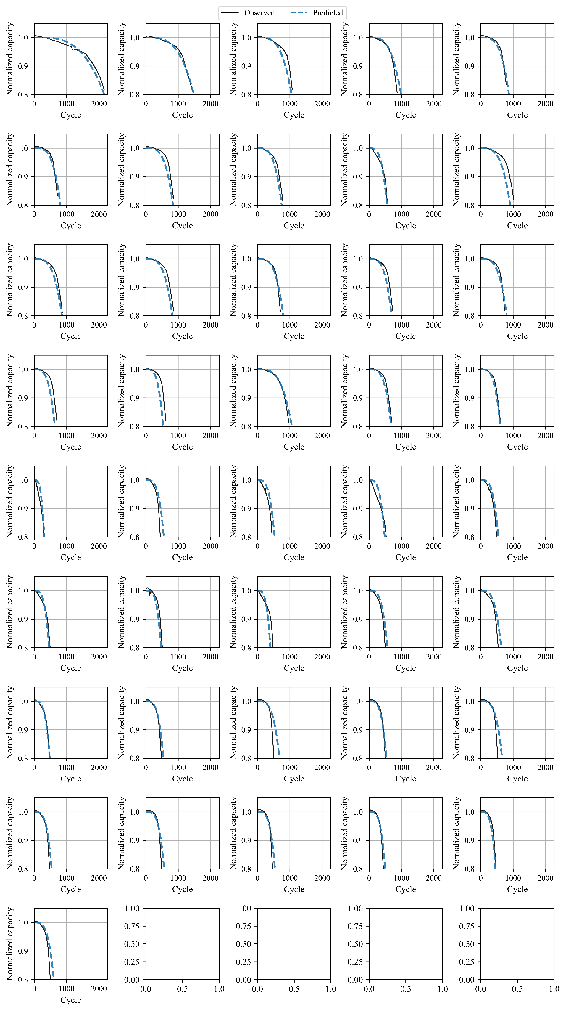

Figure S1. Predicted capacity trajectories by E2E-Elastic-discharge for the train cells of the 169 LFP dataset

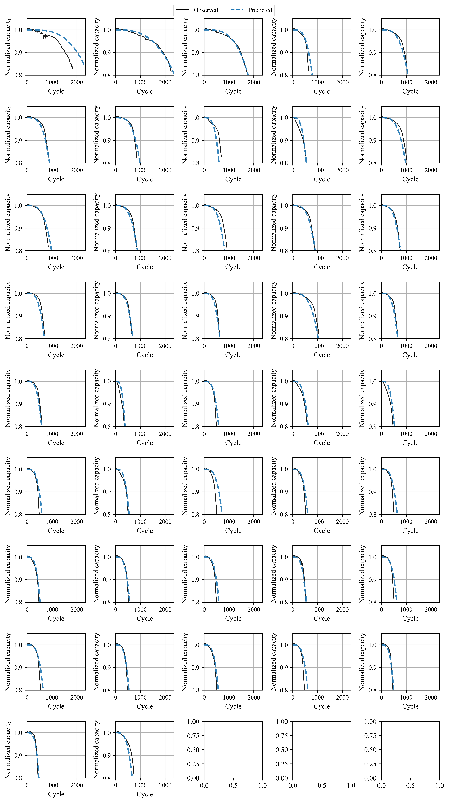

Figure S2. Predicted capacity trajectories by E2E-Elastic-discharfor the test #1 cells of the 169 LFP dataset

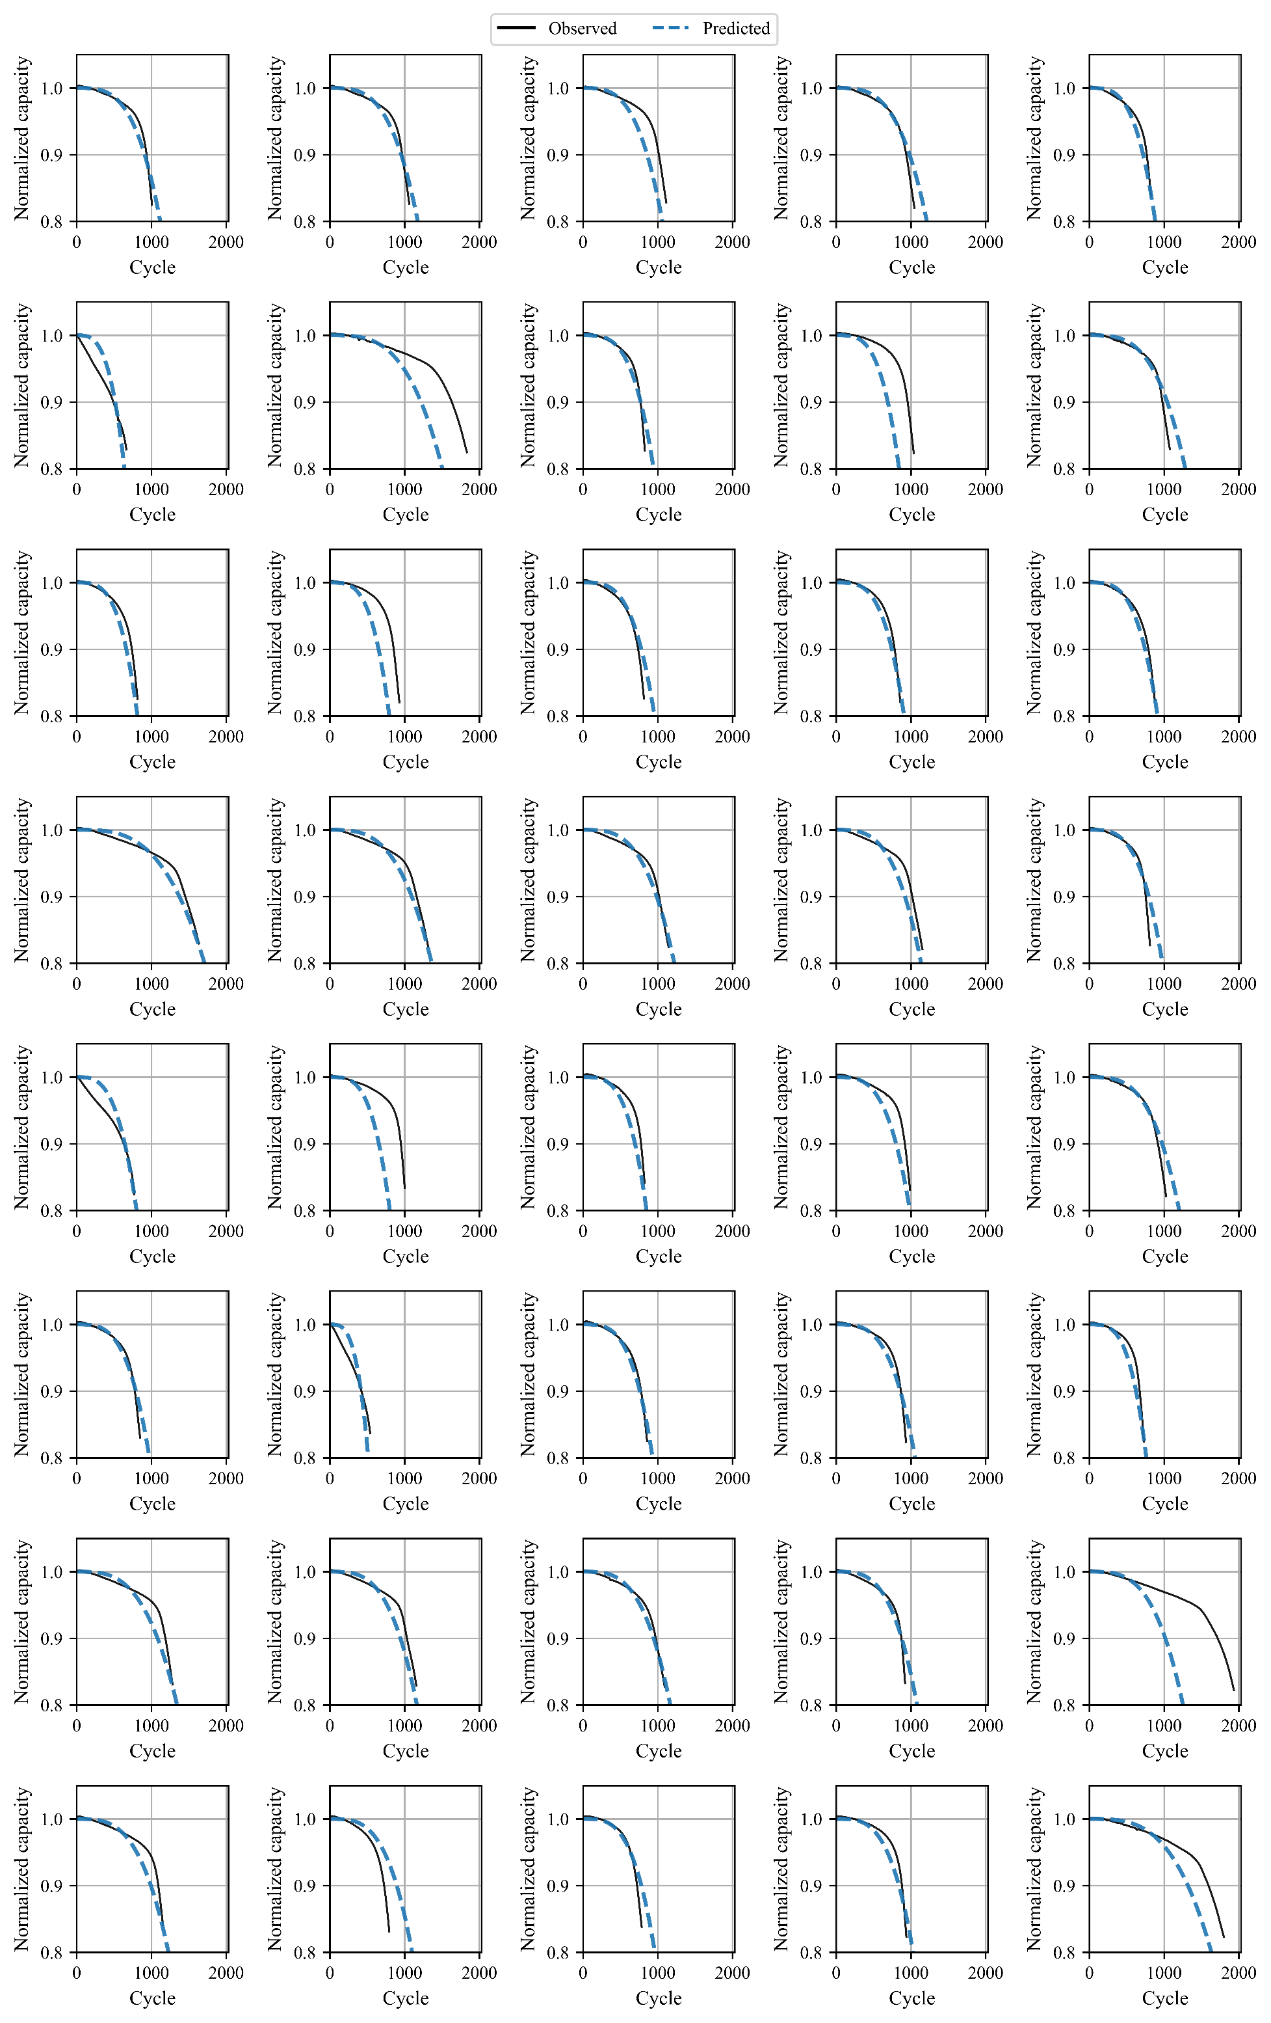

Figure S3. Predicted capacity trajectories by E2E-Elastic-discharfor the test #2 cells of the 169 LFP dataset

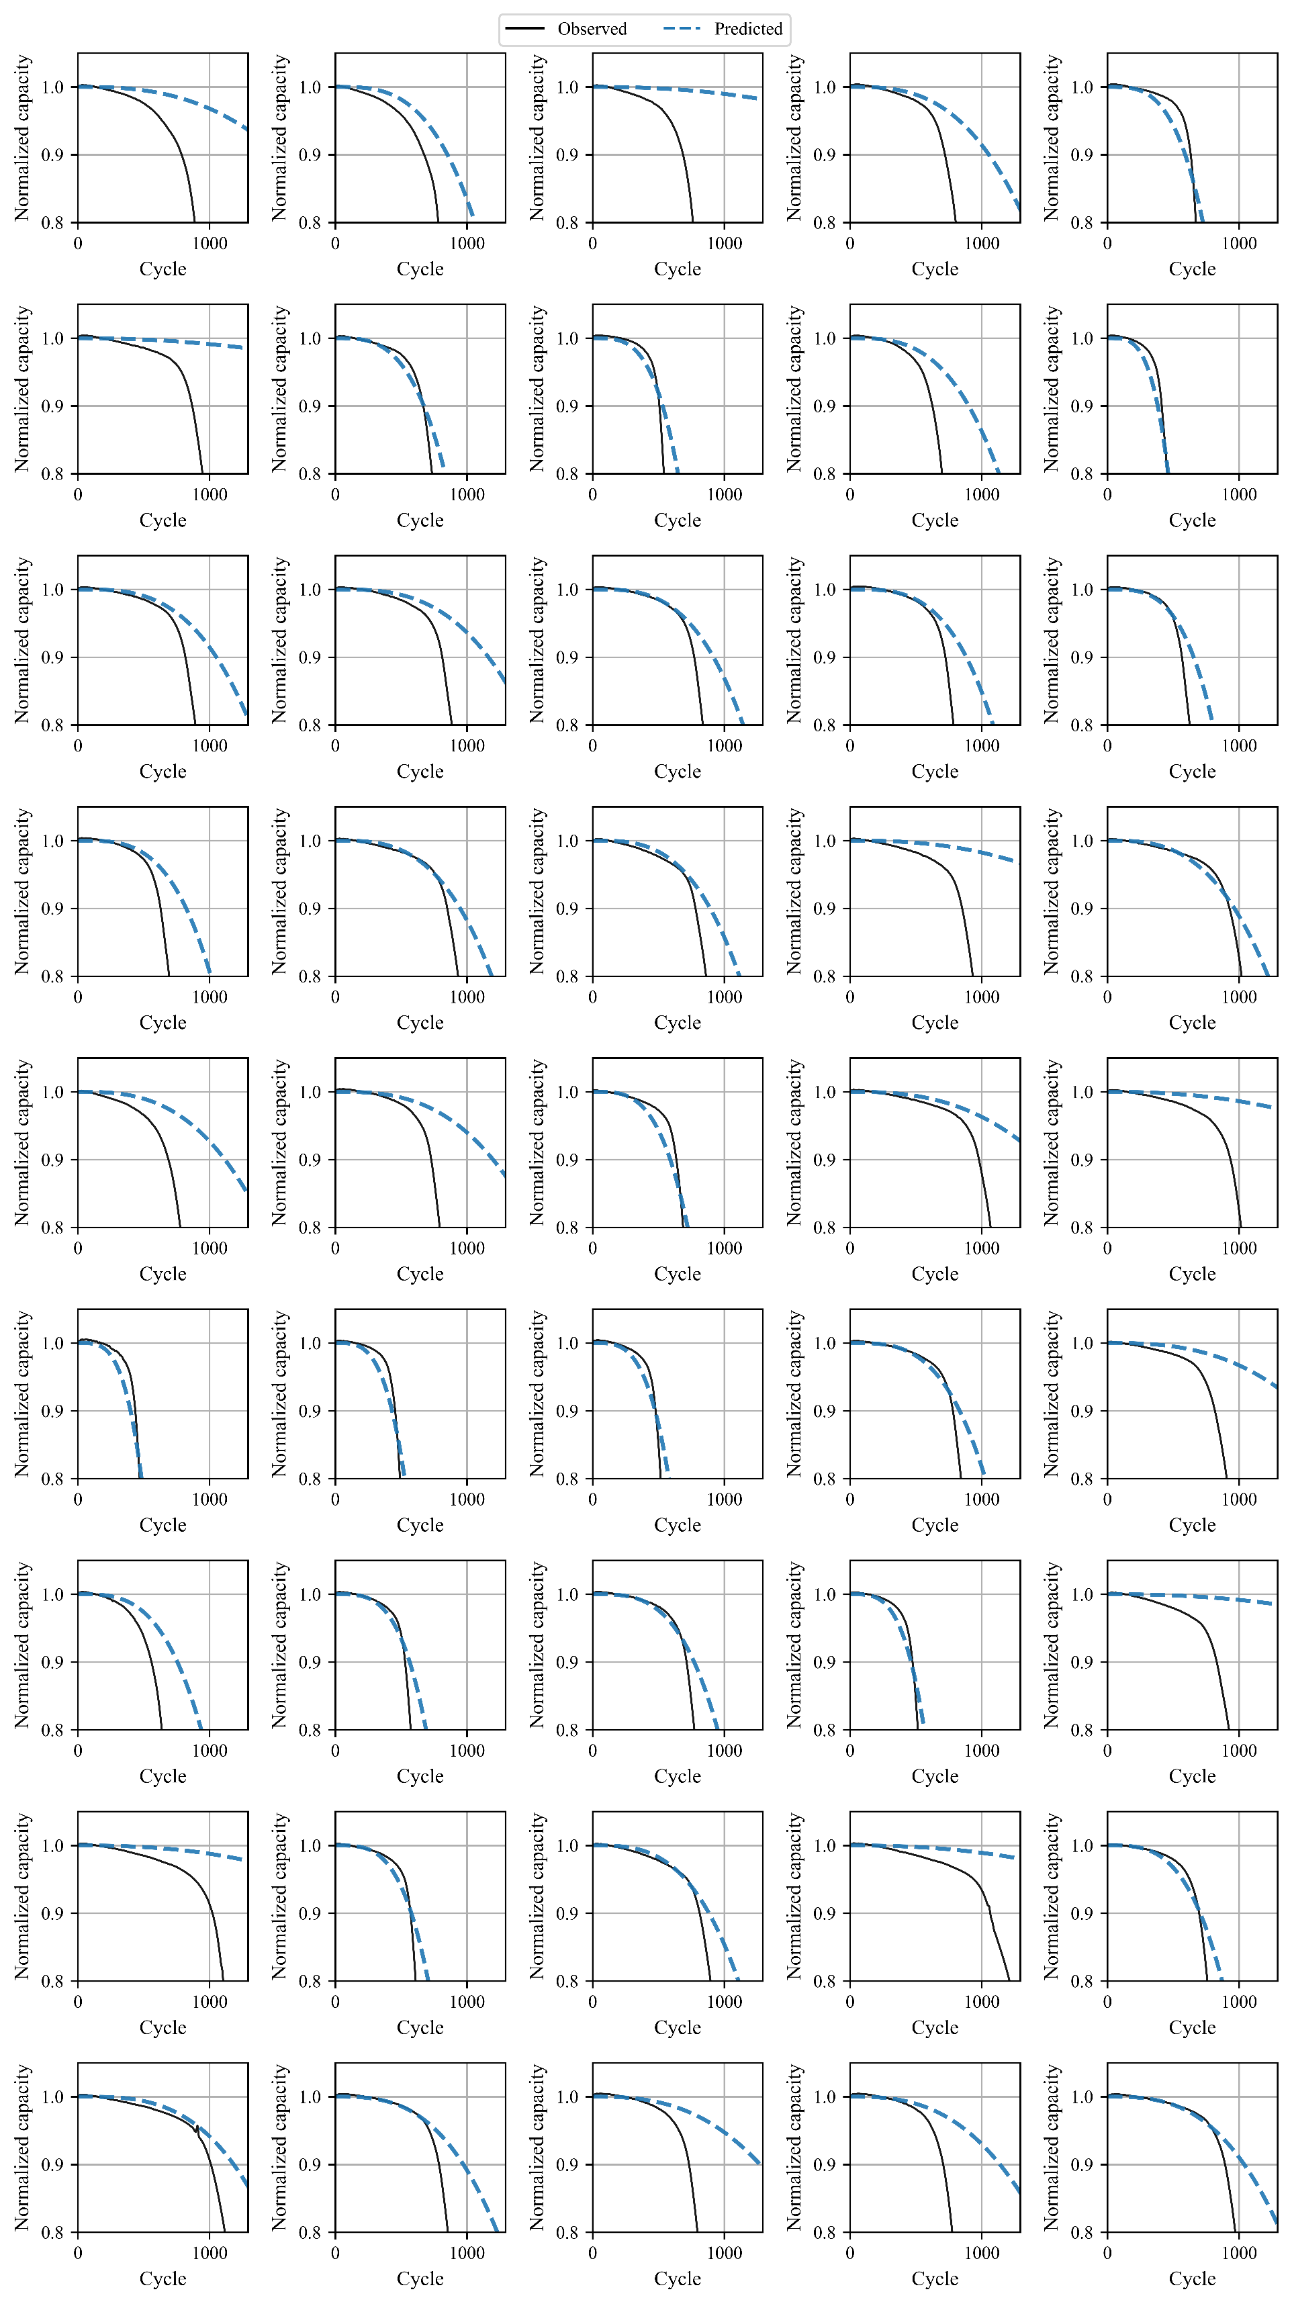

Figure S4. Predicted capacity trajectories by E2E-Elastic-discharfor the test #3 cells of the 169 LFP dataset

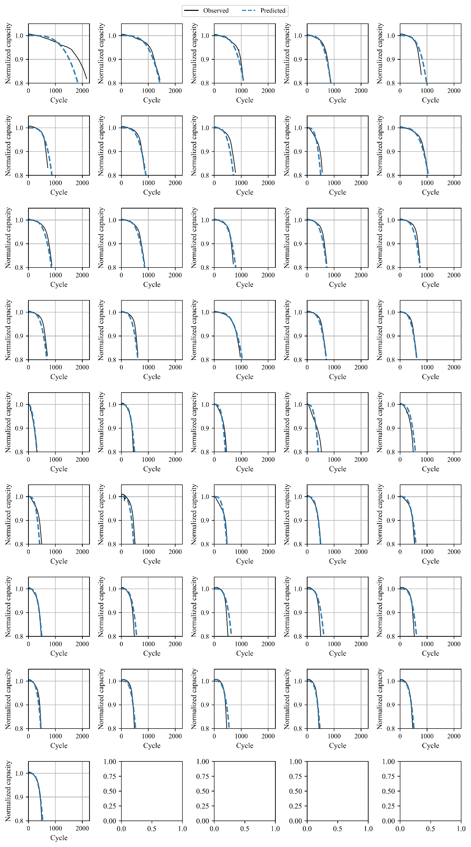

Figure S5. Predicted capacity trajectories by E2E-Elastic-deltaQ for the train cells of the 169 LFP dataset

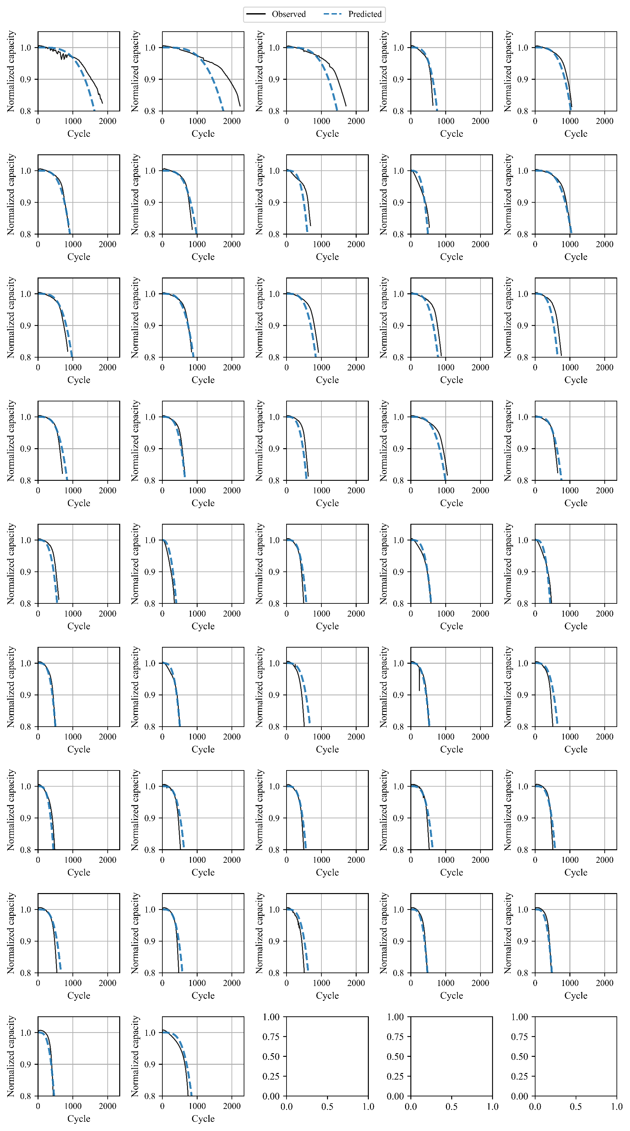

Figure S6. Predicted capacity trajectories by E2E-Elastic-deltaQ for the test #1 cells of the 169 LFP dataset

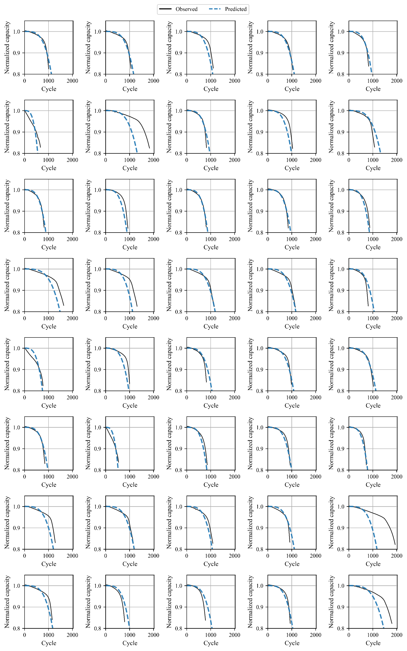

Figure S7. Predicted capacity trajectories by E2E-Elastic-deltaQ for the test #2 cells of the 169 LFP dataset

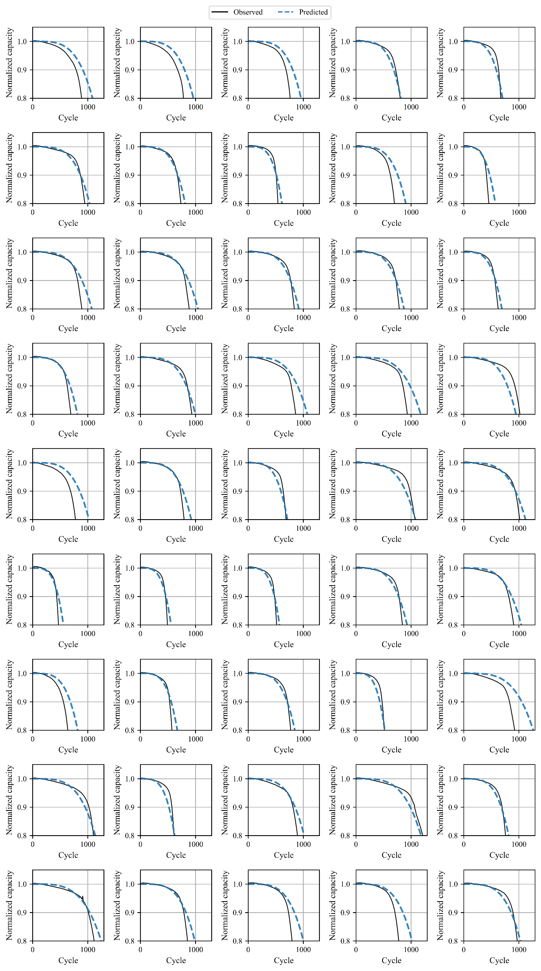

Figure S8. Predicted capacity trajectories by E2E-Elastic-deltaQ for the test #3 cells of the 169 LFP dataset

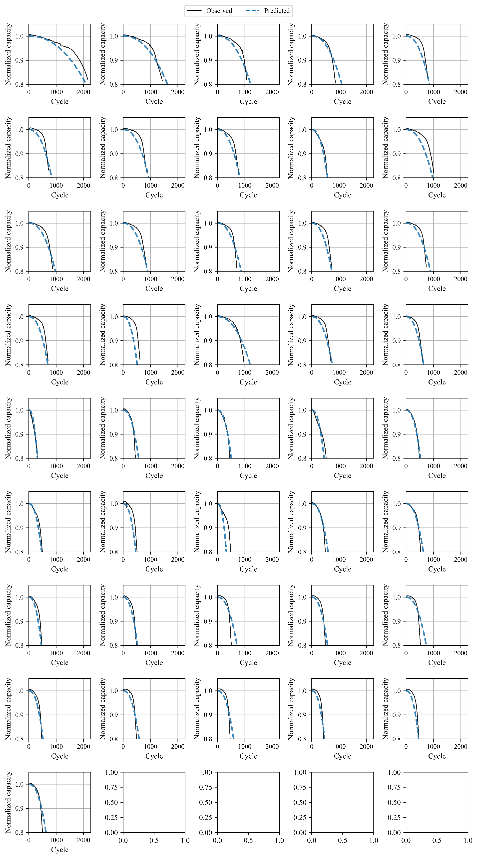

Figure S9. Predicted capacity trajectories by E2E-ENN- discharge for the train cells of the 169 LFP dataset.

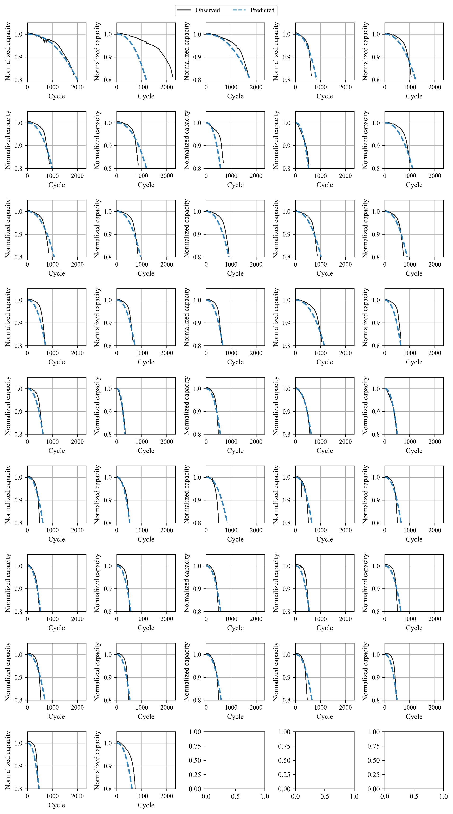

Figure S10. Predicted capacity trajectories by E2E- ENN- discharge for the test #1 cells of the 169 LFP dataset

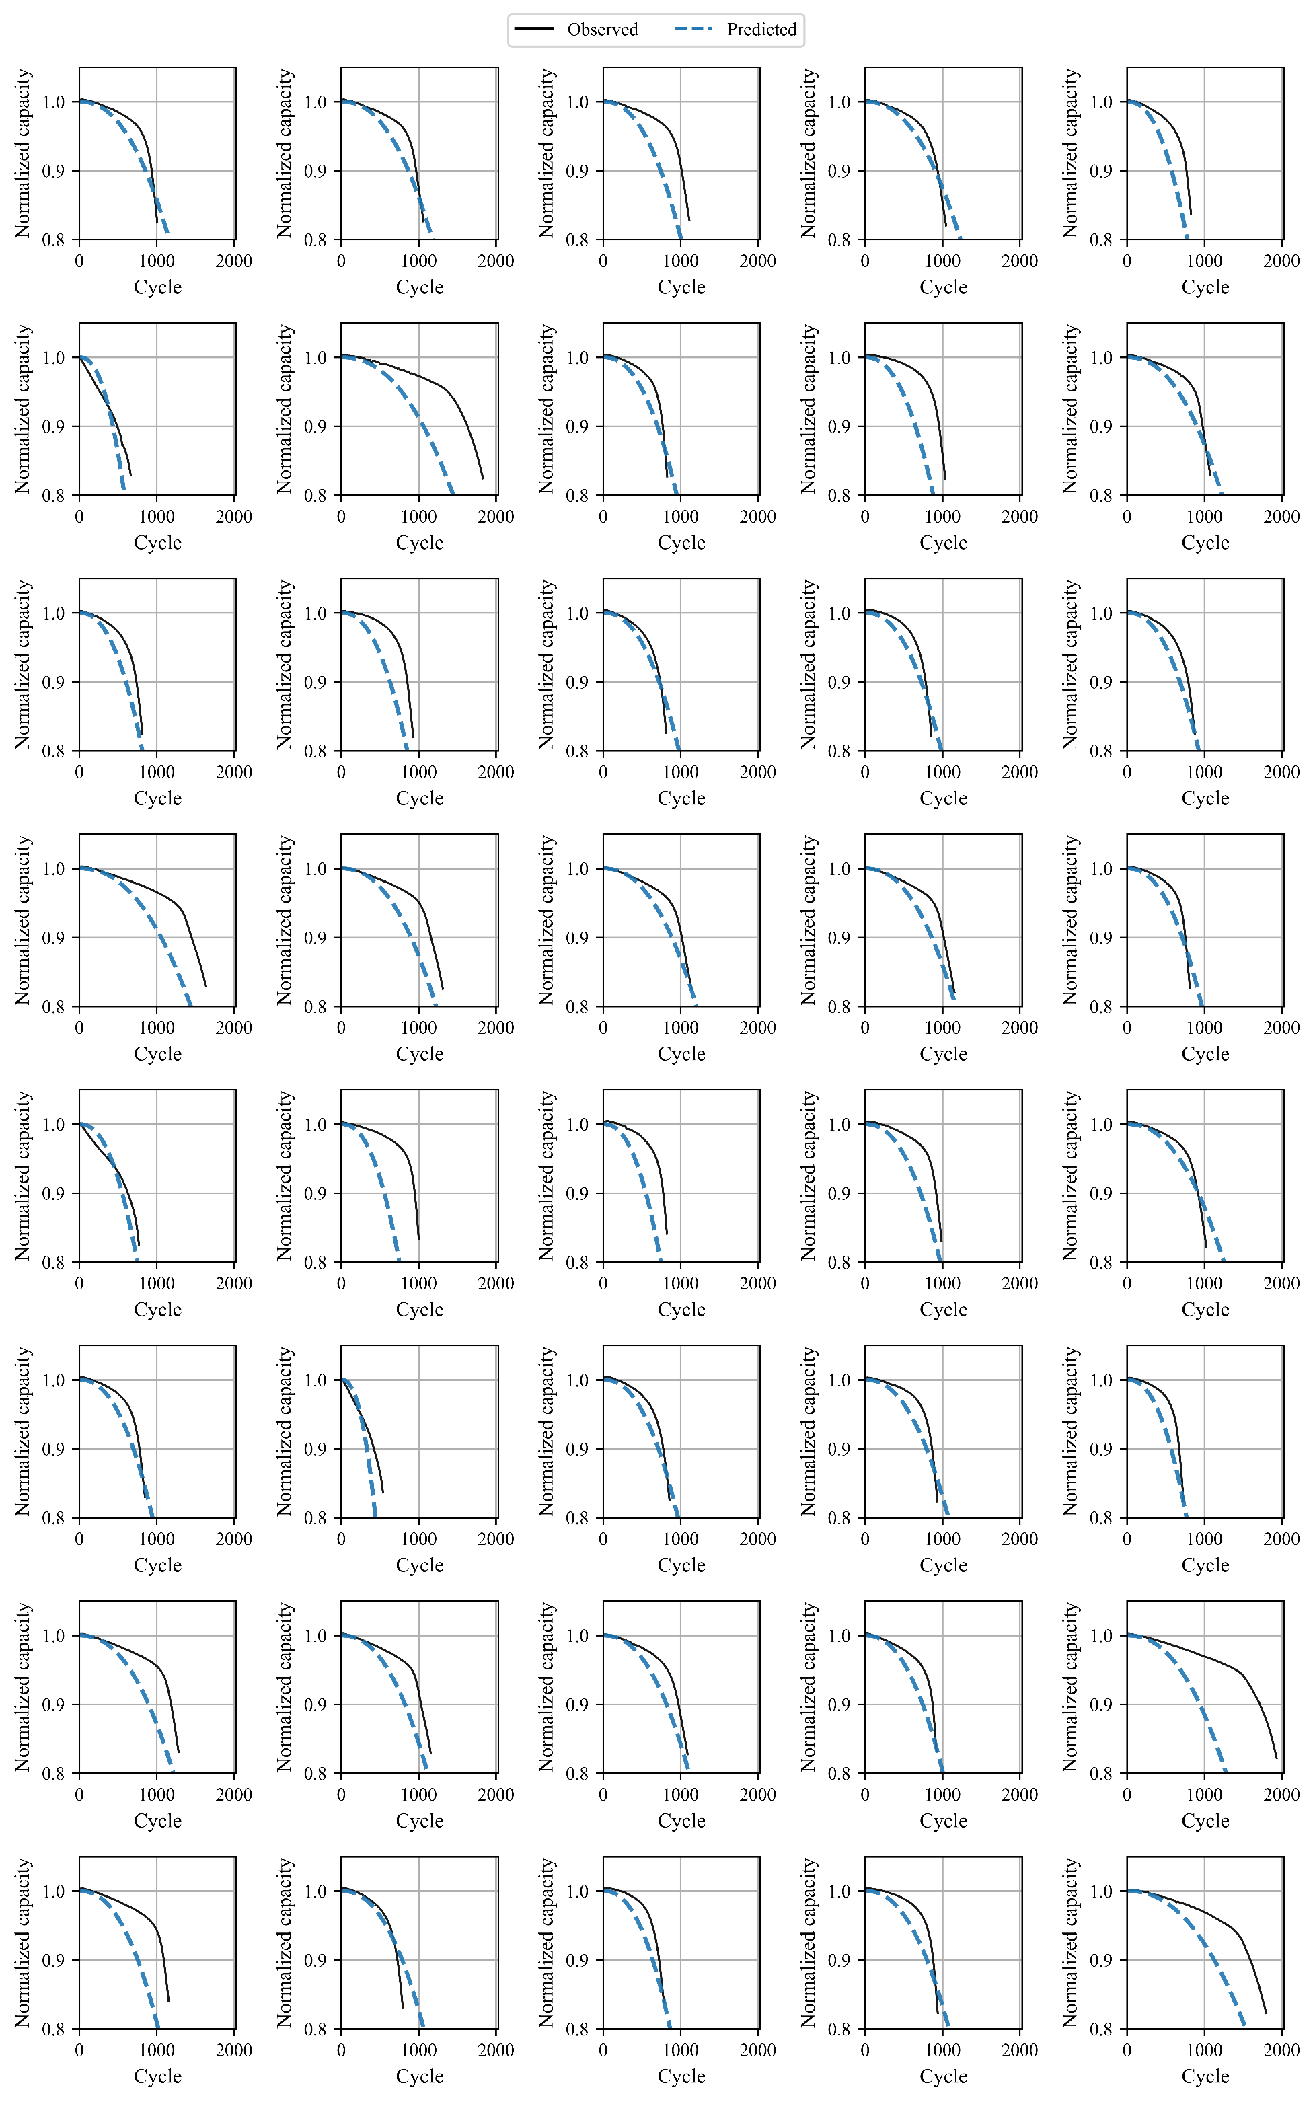

Figure S11. Predicted capacity trajectories by E2E- ENN- discharge for the test #2 cells of the 169 LFP dataset

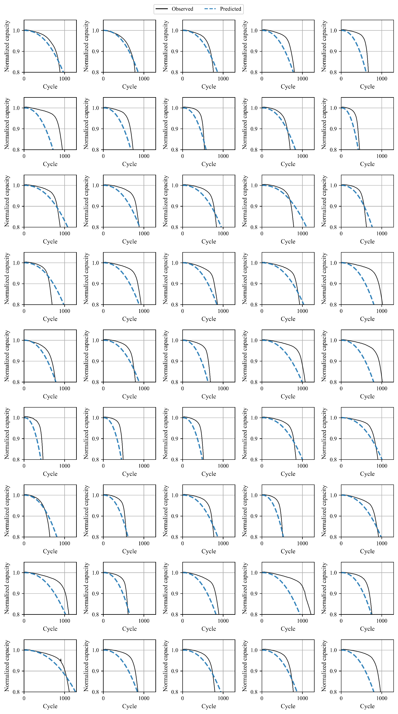

Figure S12. Predicted capacity trajectories by E2E-ENN- discharge for the test #3 cells of the 169 LFP dataset.

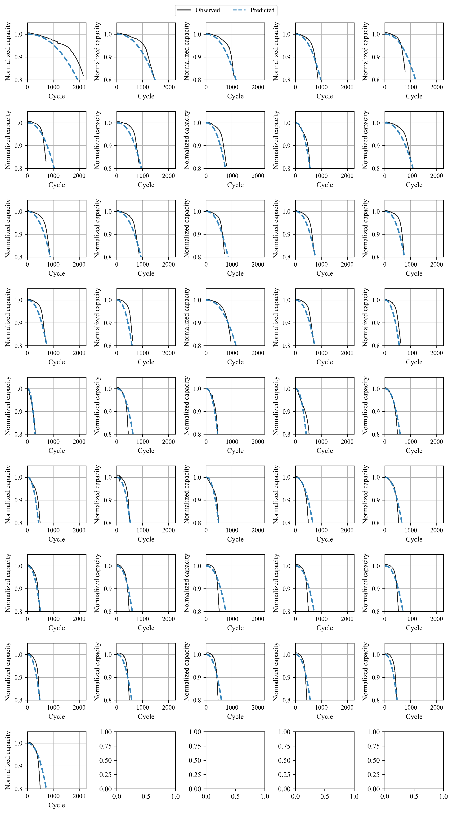

Figure S13. Predicted capacity trajectories by E2E-ENN-deltaQ for the train cells of the 169 LFP dataset.

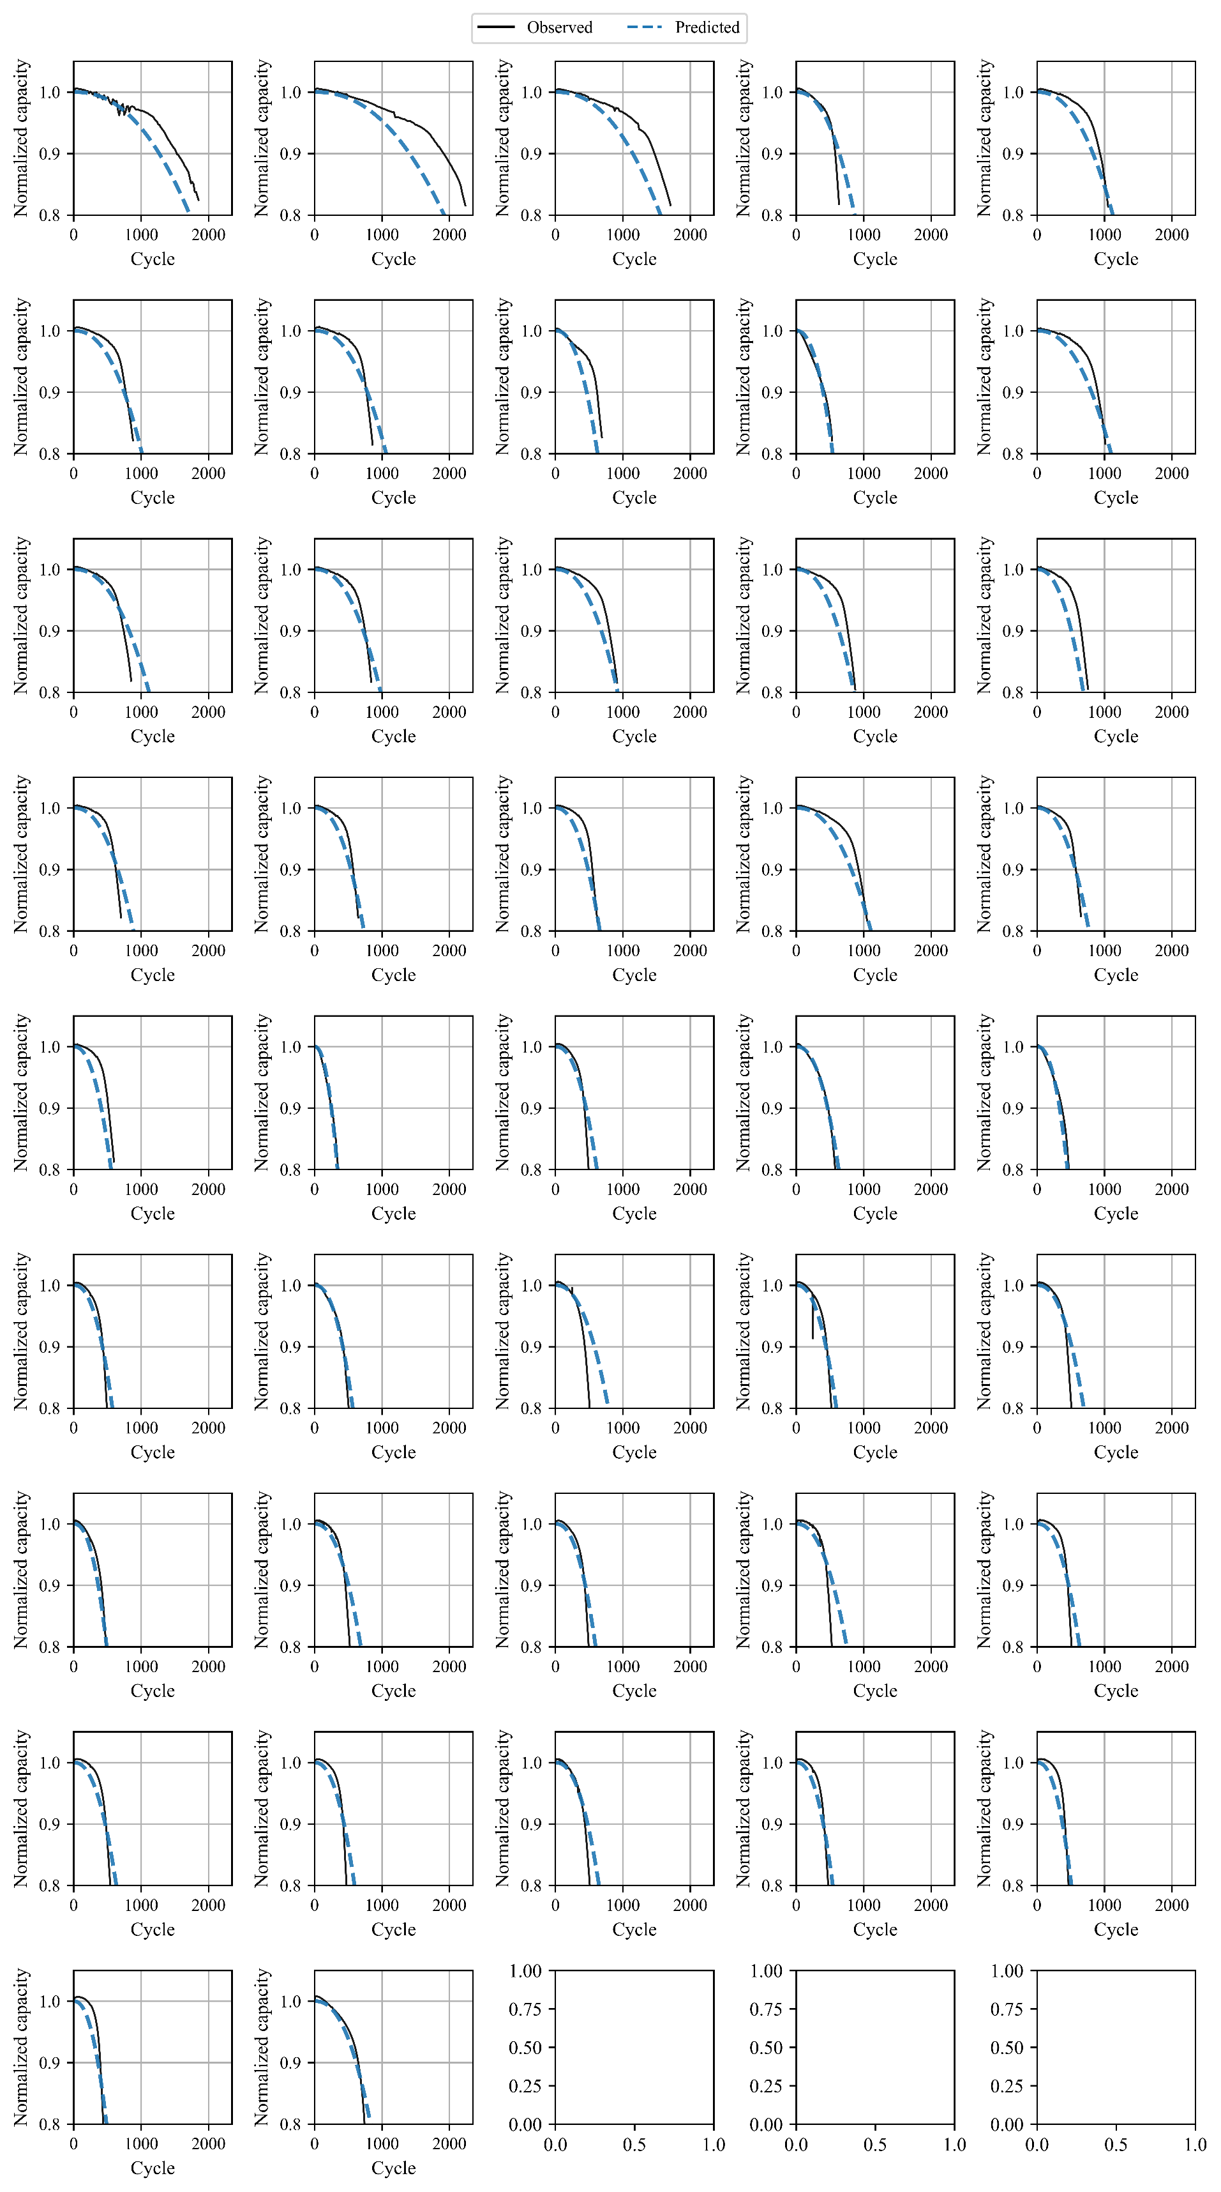

Figure S14. Predicted capacity trajectories by E2E-ENN-deltaQ for the test #1 cells of the 169 LFP dataset

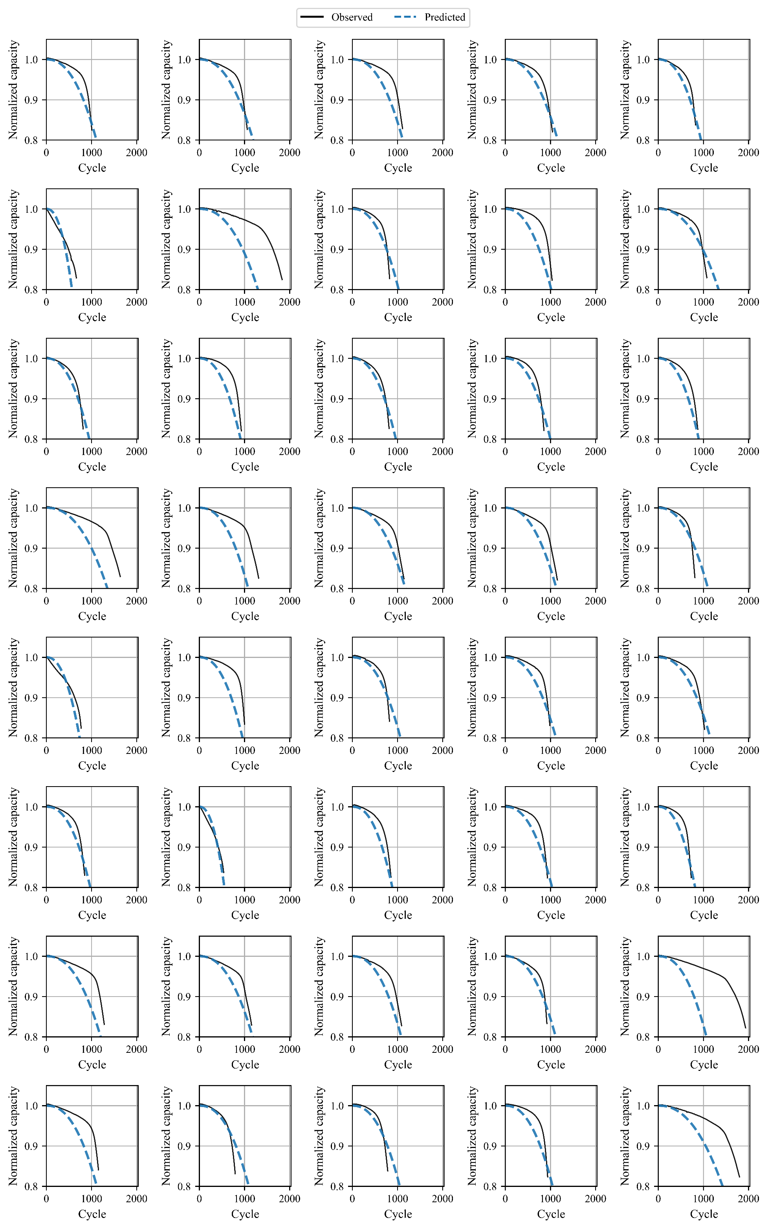

Figure S15. Predicted capacity trajectories by E2E-ENN-deltaQ for the test #2 cells of the 169 LFP dataset

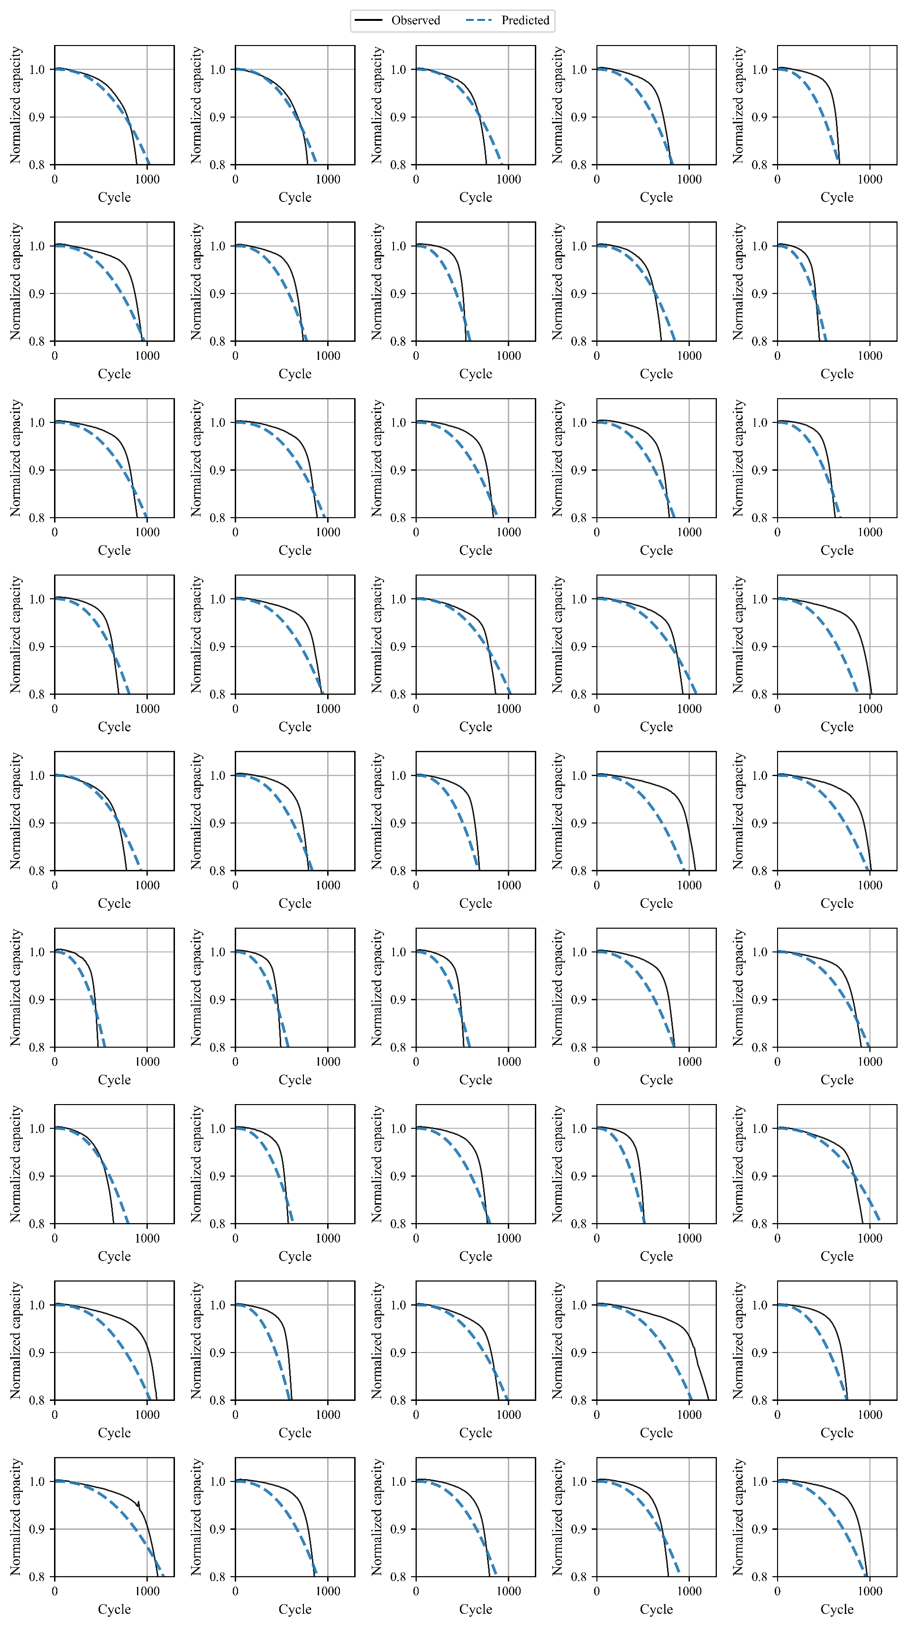

Figure S16. Predicted capacity trajectories by E2E-ENN-deltaQ for the test #3 cells of the 169 LFP dataset

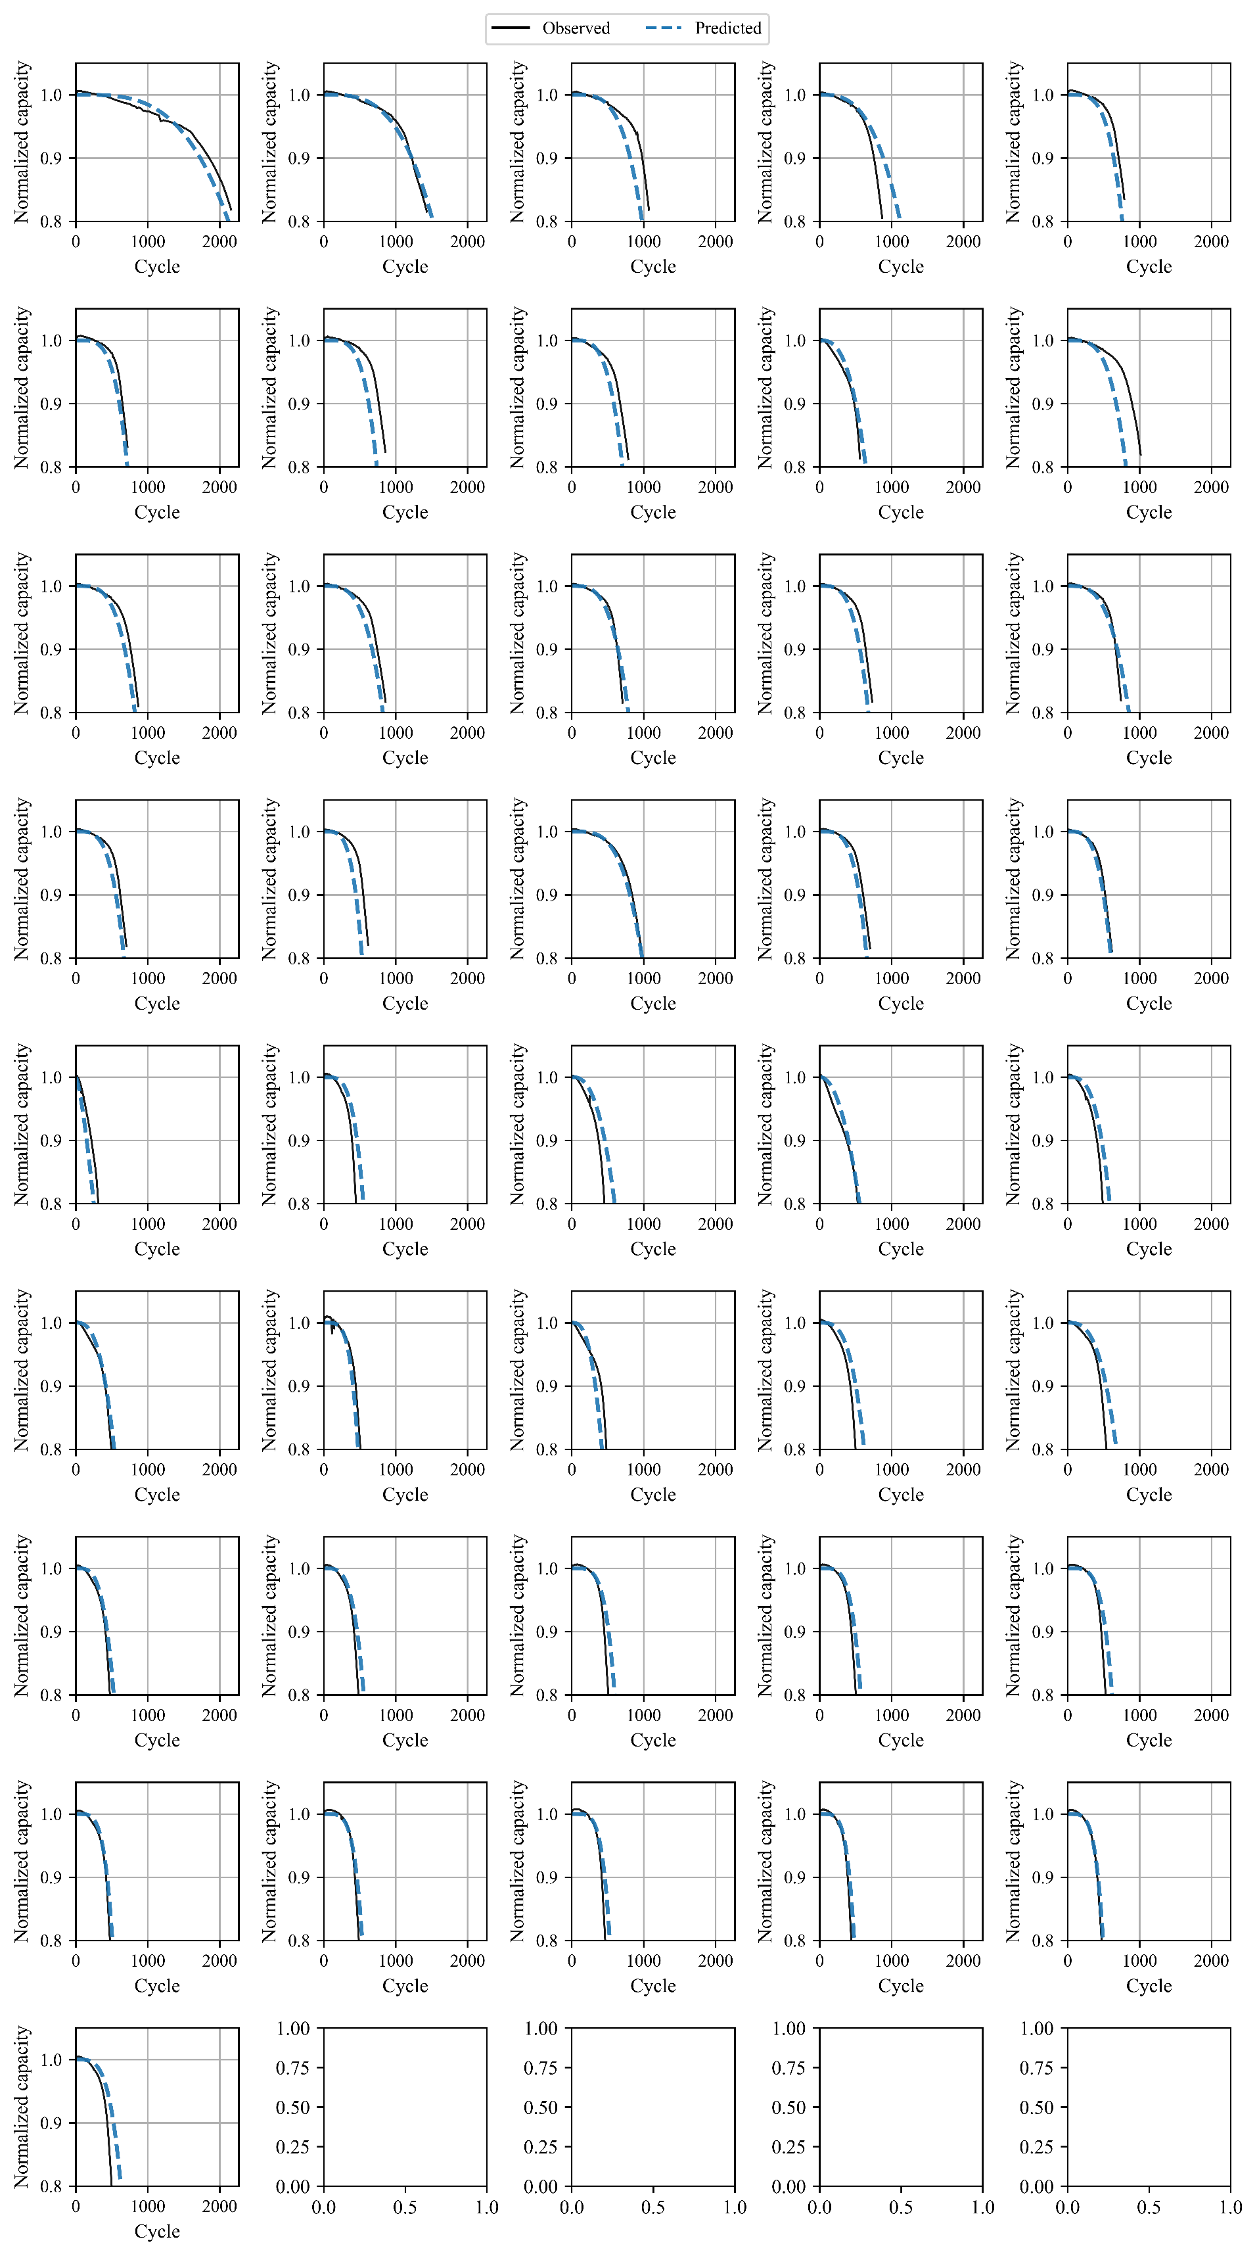

Figure S17. Predicted capacity trajectories by SeqOpt-Elastic-discharge for the train cells of the 169 LFP dataset.

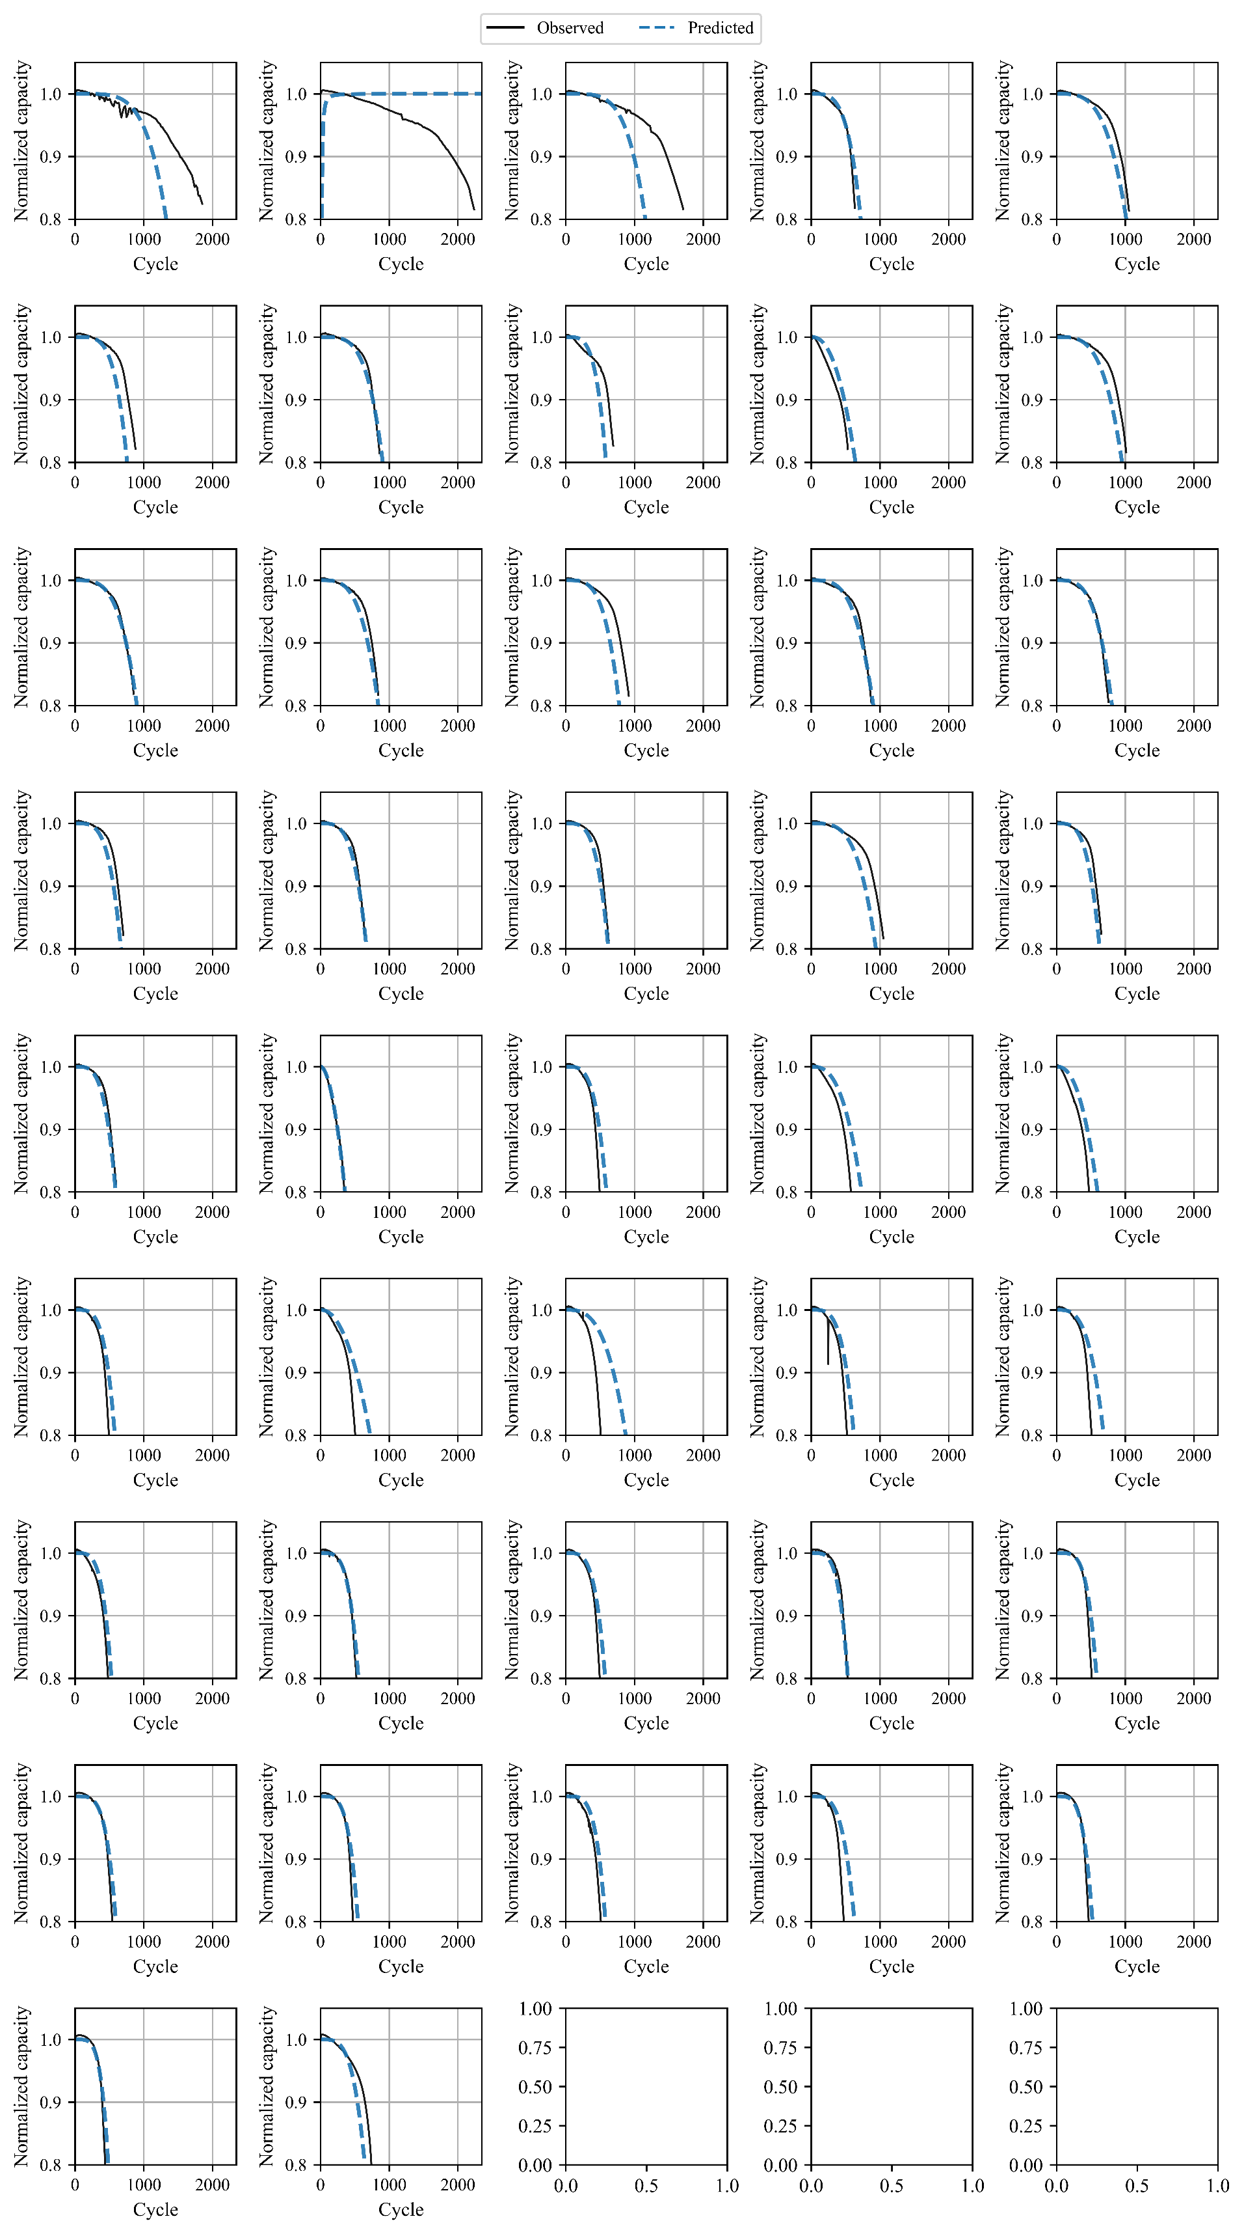

Figure S18. Predicted capacity trajectories by SeqOpt-Elastic-discharge for the test #1 cells of the 169 LFP dataset

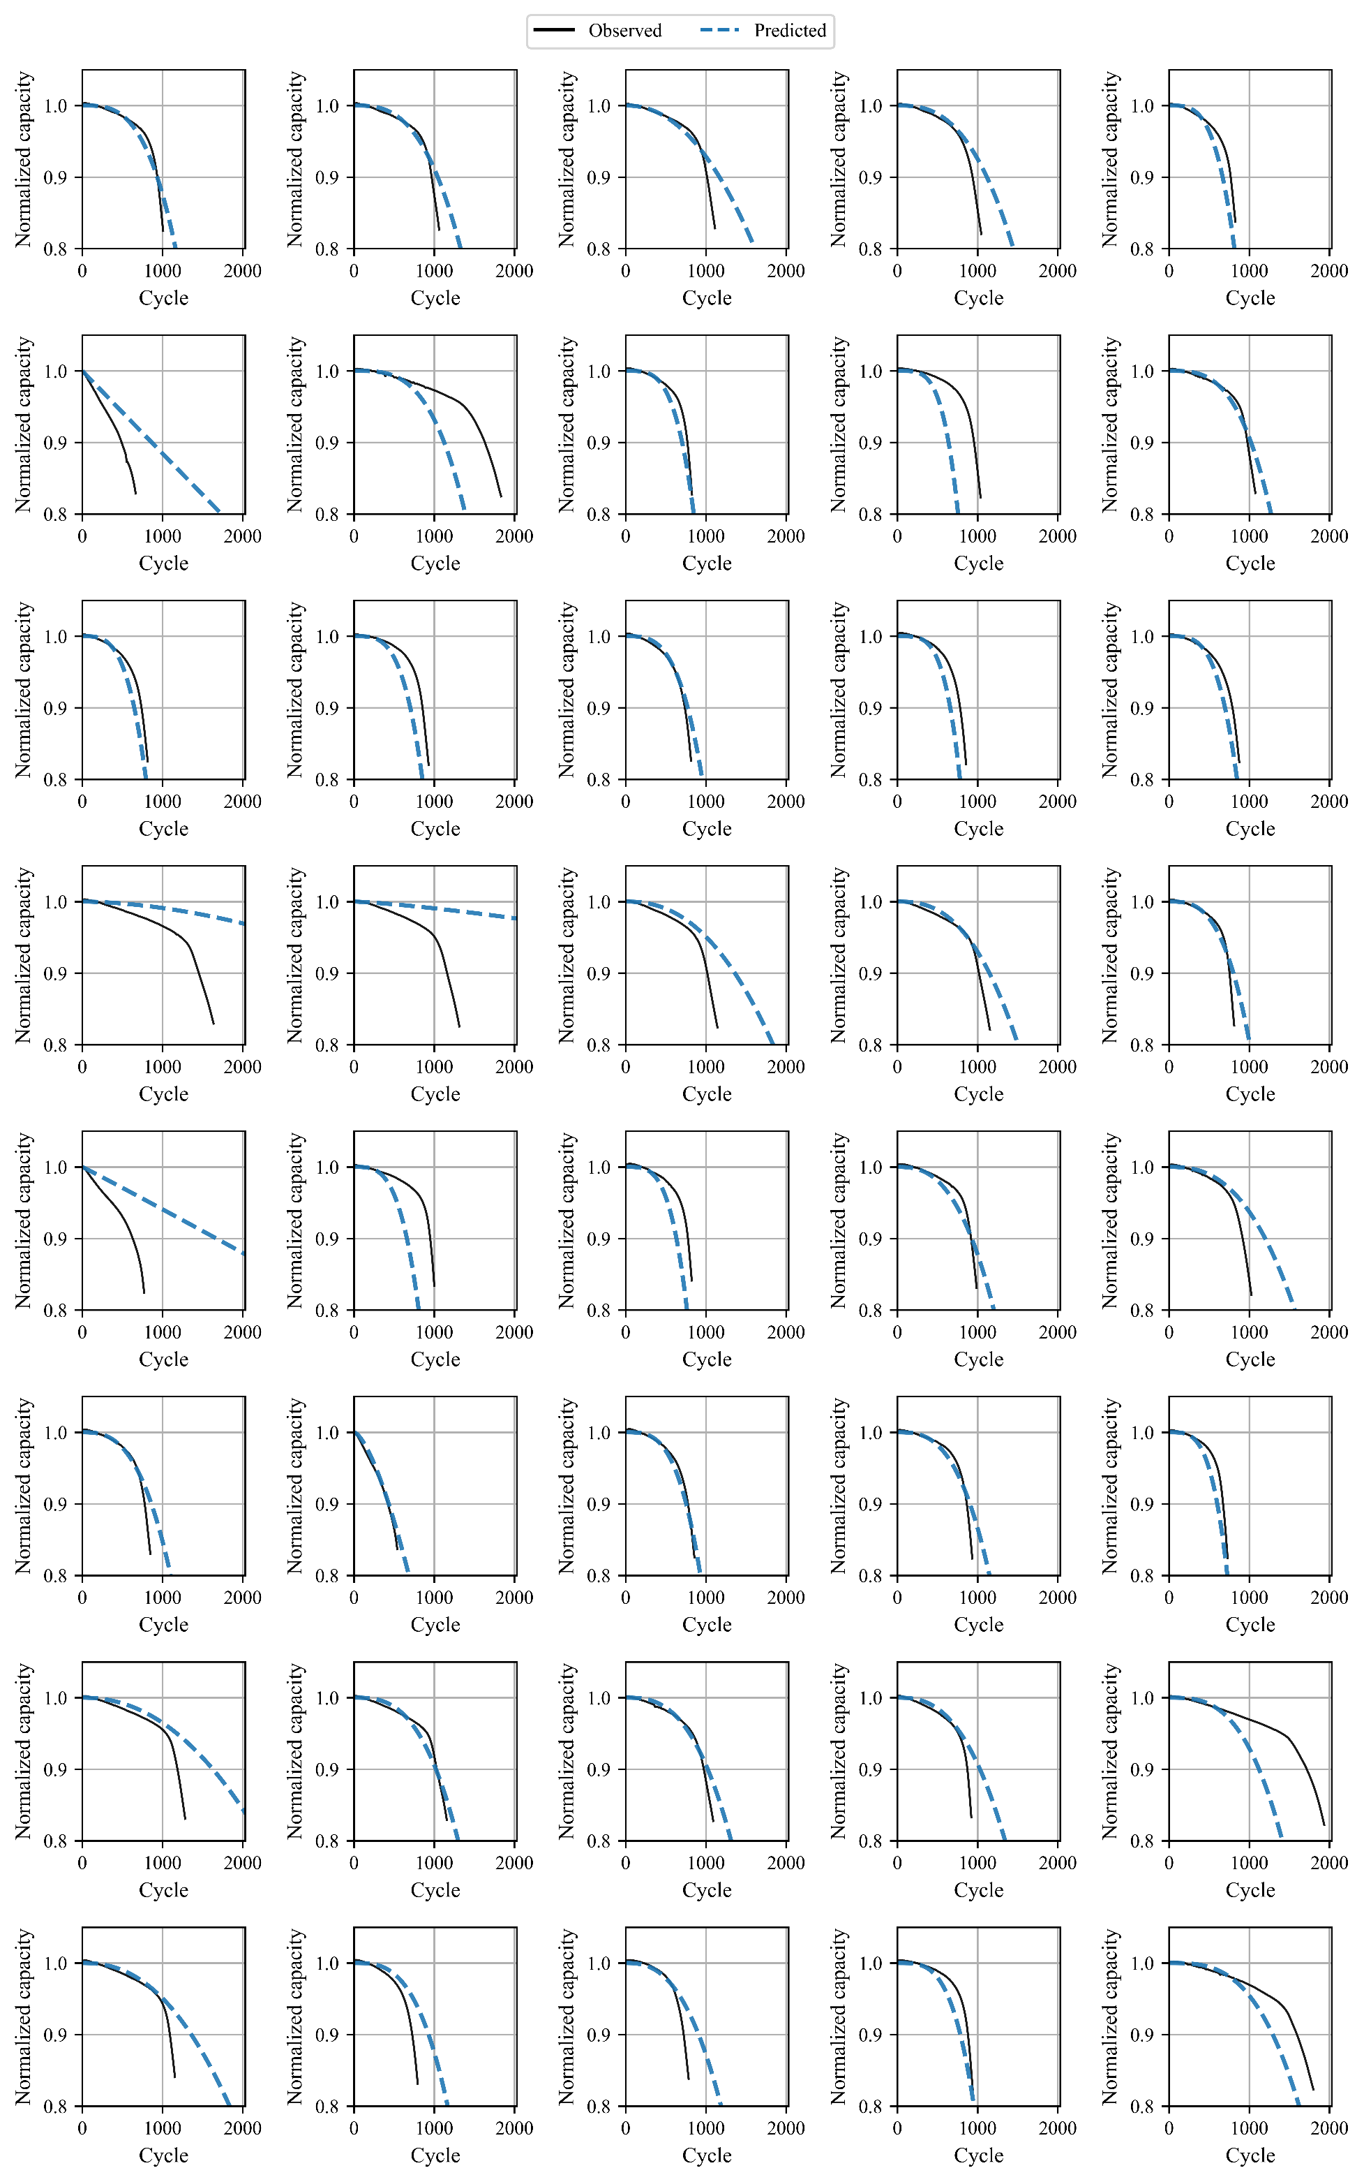

Figure S19. Predicted capacity trajectories by SeqOpt-Elastic-discharge for the test #2 cells of the 169 LFP dataset

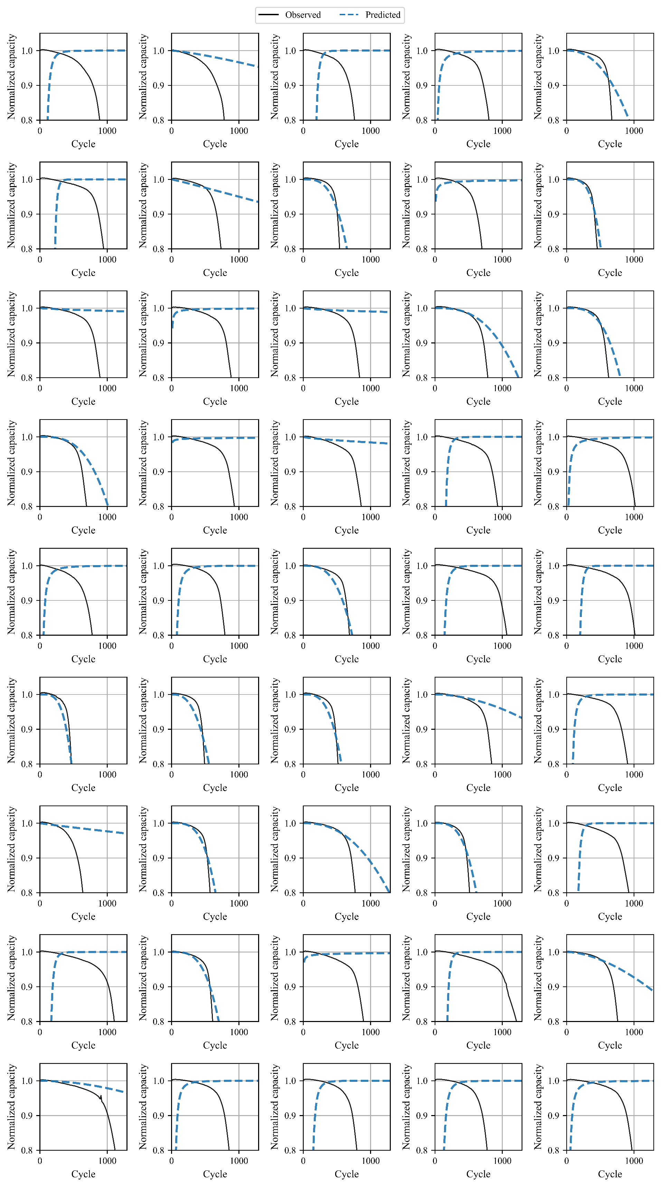

Figure S20. Predicted capacity trajectories by SeqOpt-Elastic-discharge for the test #3 cells of the 169 LFP dataset

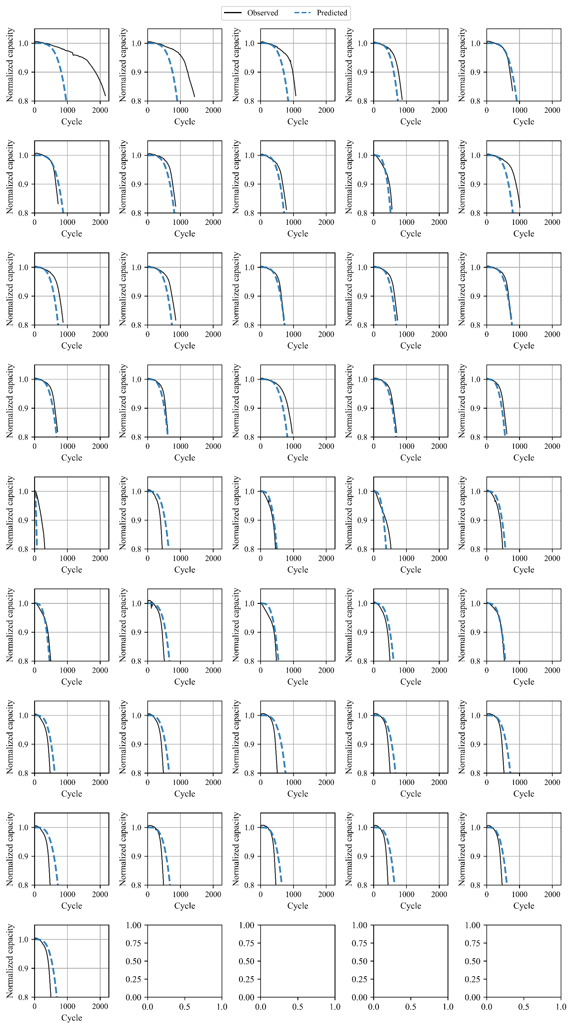

Figure S21. Predicted capacity trajectories by SeqOpt-Elastic-deltaQ for the train cells of the 169 LFP dataset

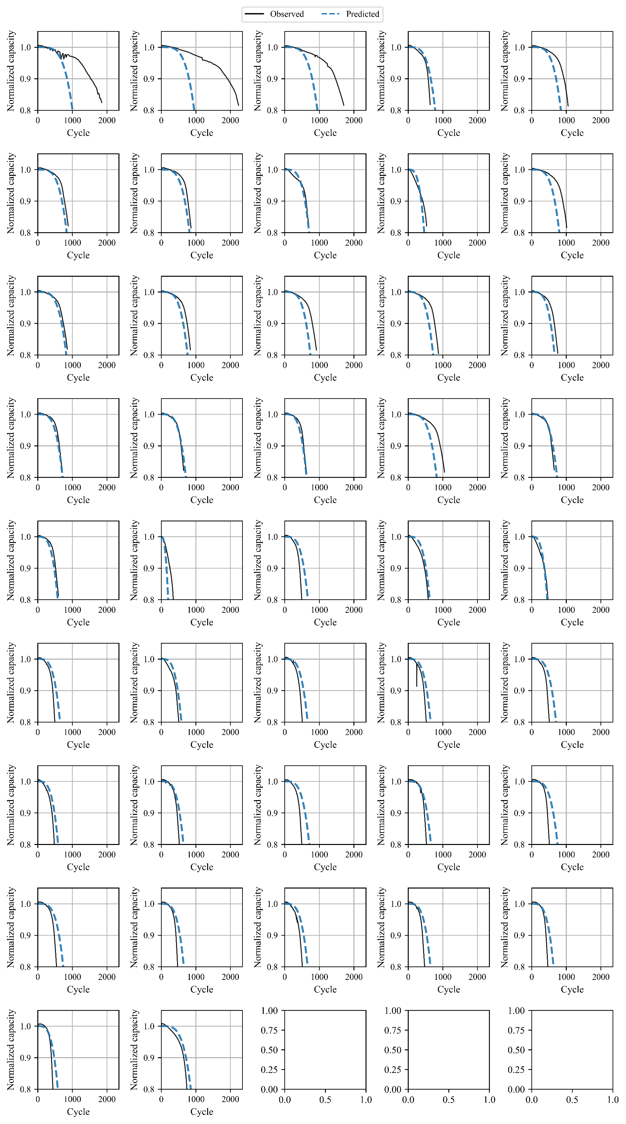

Figure S22. Predicted capacity trajectories by SeqOpt-Elastic-deltaQ for the test #1 cells of the 169 LFP dataset

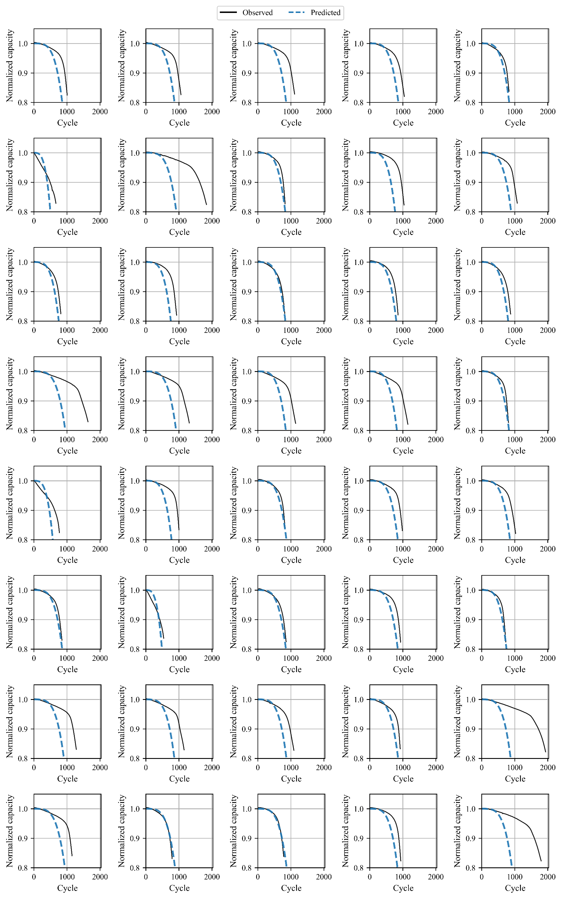

Figure S23. Predicted capacity trajectories by SeqOpt-Elastic-deltaQ for the test #2 cells of the 169 LFP dataset

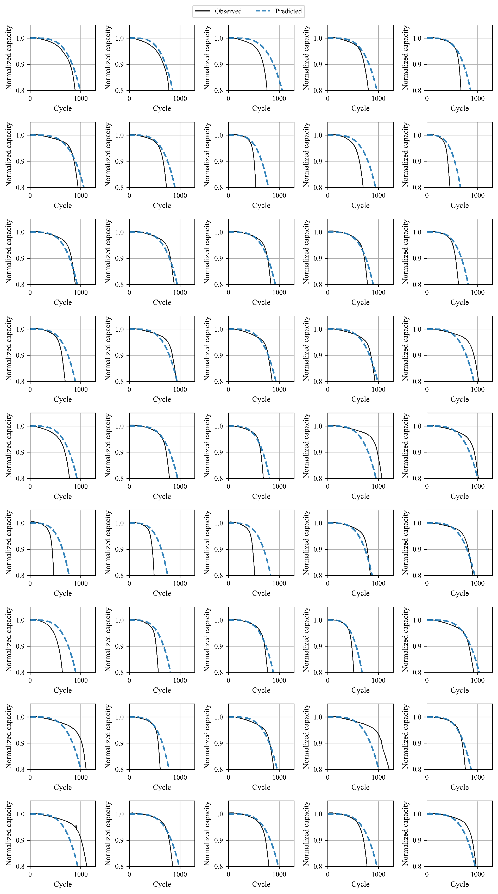

Figure S24. Predicted capacity trajectories by SeqOpt-Elastic-deltaQ for the test #3 cells of the 169 LFP dataset

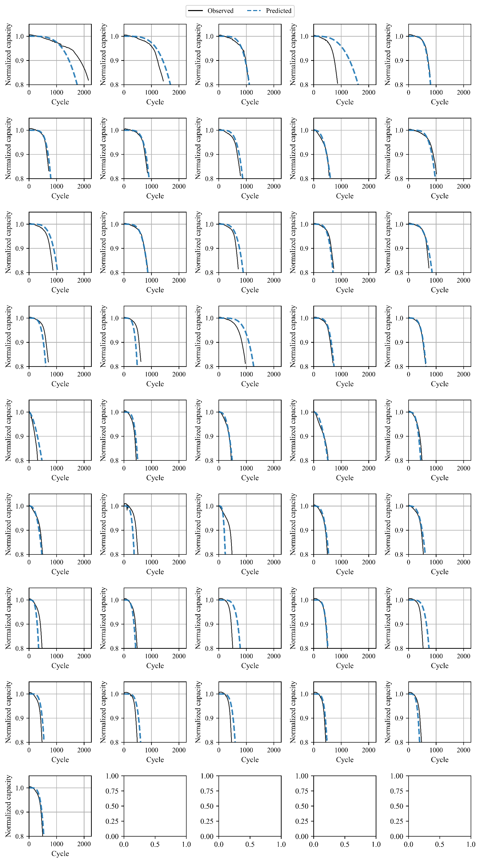

Figure S25. Predicted capacity trajectories by SeqOpt-ENN-discharge for the train cells of the 169 LFP dataset.

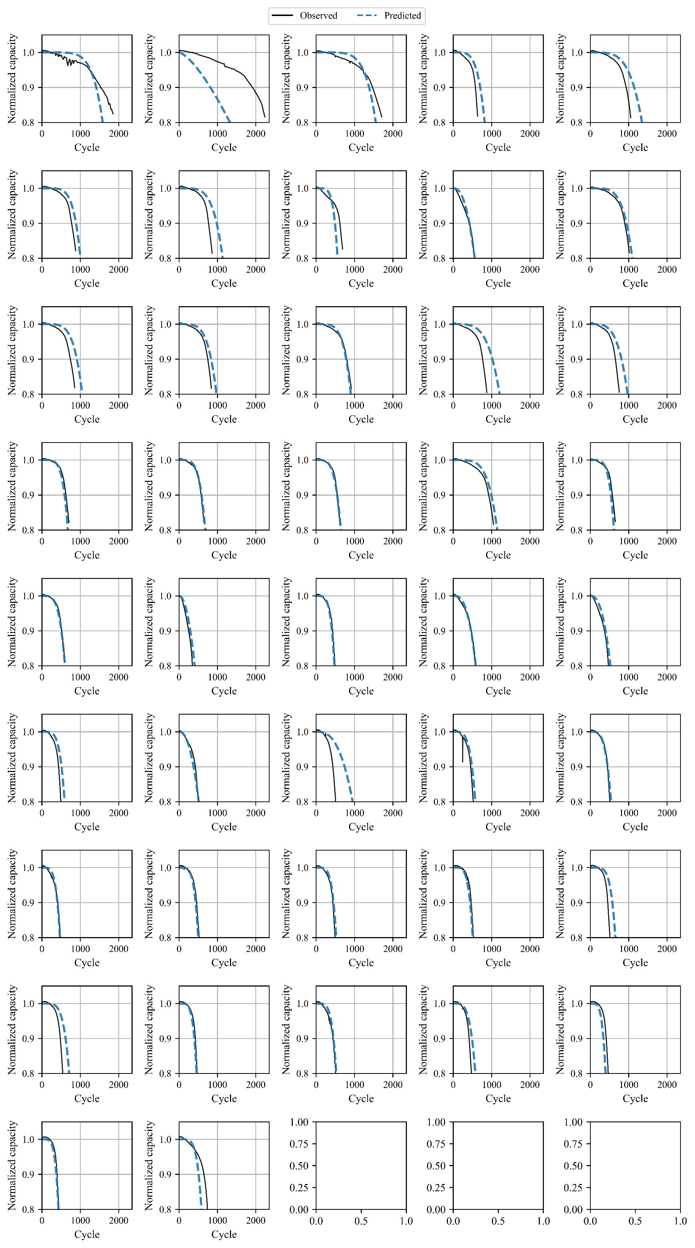

Figure S26. Predicted capacity trajectories by SeqOpt-ENN-discharge for the test #1 cells of the 169 LFP dataset

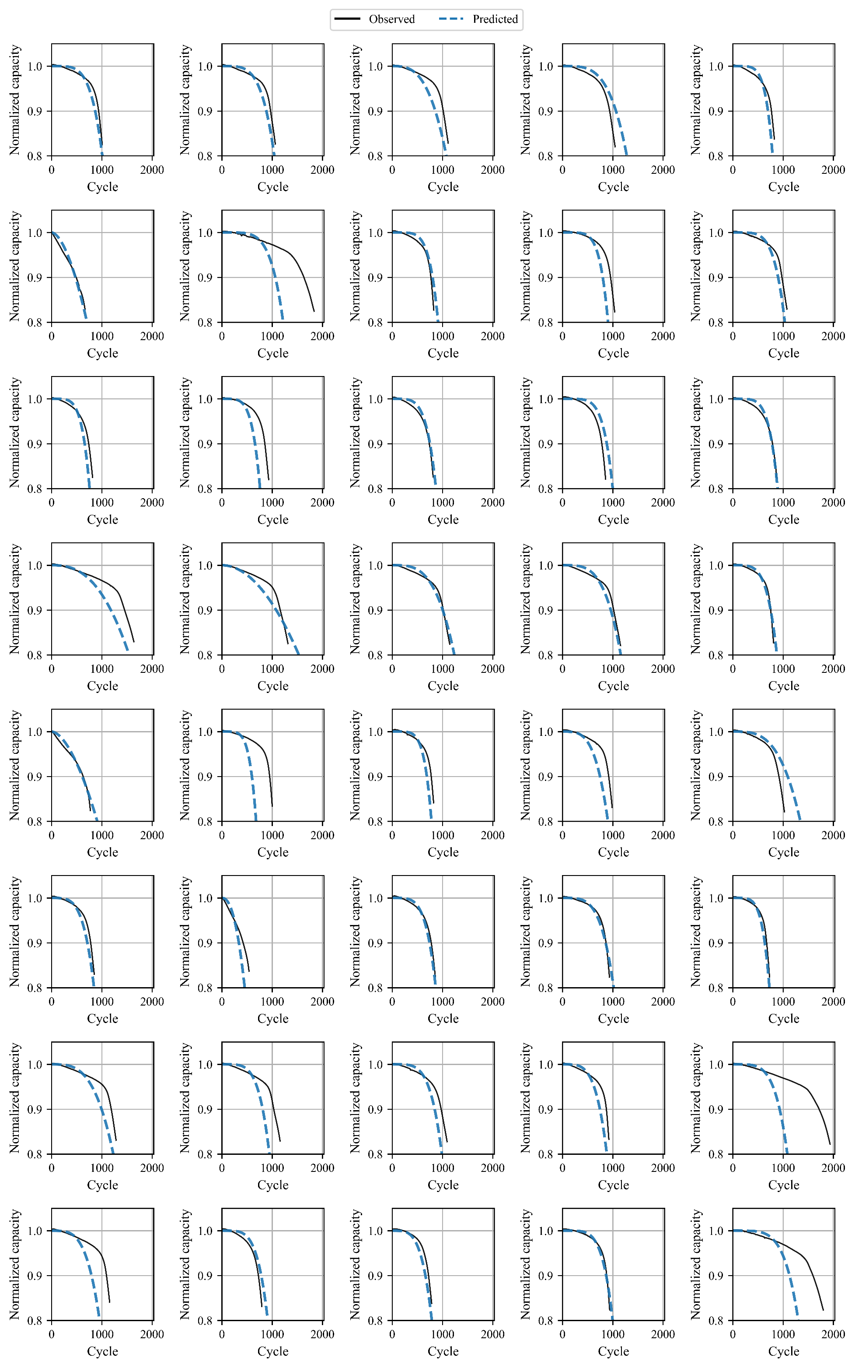

Figure S27. Predicted capacity trajectories by SeqOpt-ENN-discharge for the test #2 cells of the 169 LFP dataset

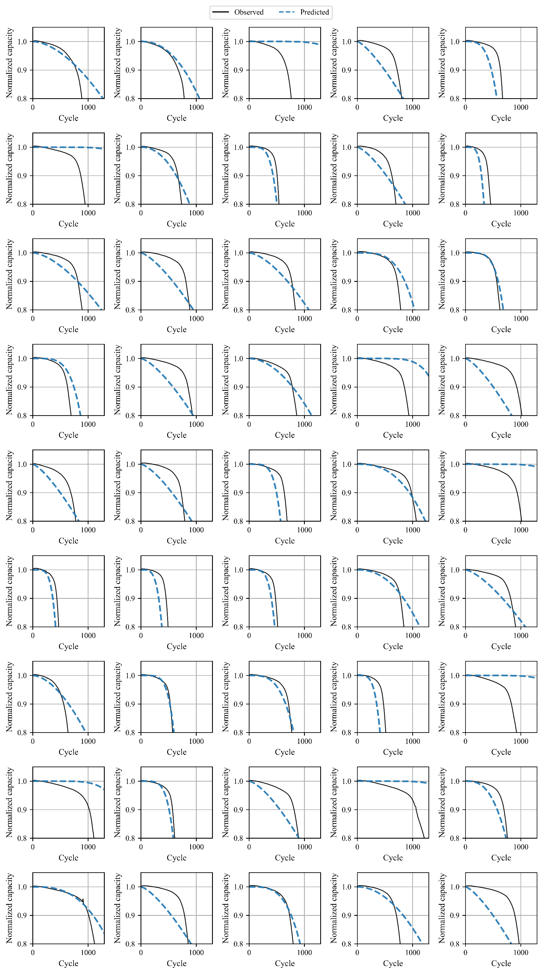

Figure S28. Predicted capacity trajectories by SeqOpt-ENN-discharge for the test #3 cells of the 169 LFP dataset

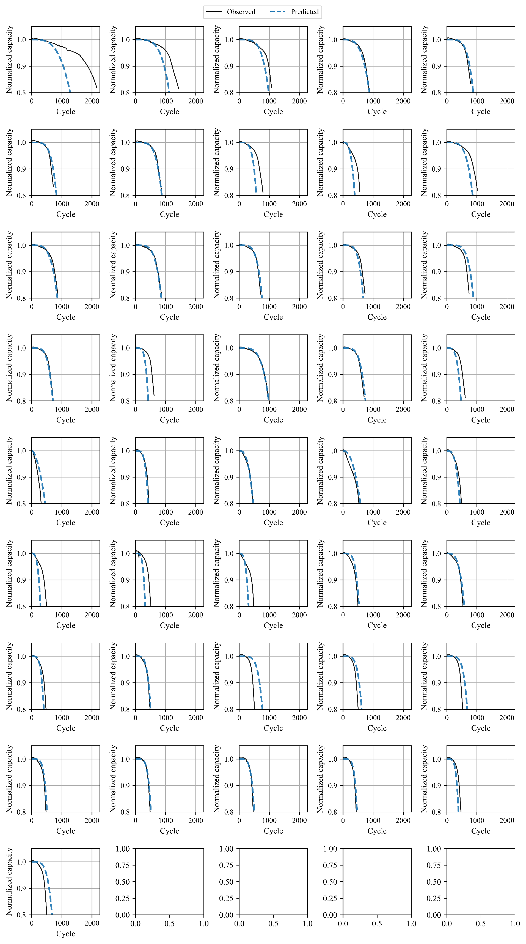

Figure S29. Predicted capacity trajectories by SeqOpt-ENN-deltaQ for the train cells of the 169 LFP dataset

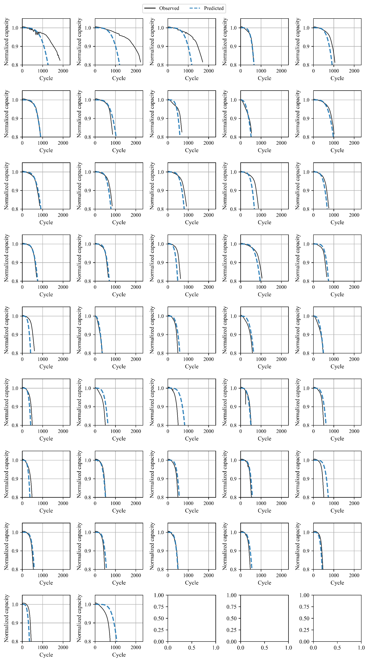

Figure S30. Predicted capacity trajectories by SeqOpt-ENN-deltaQ for the test #1 cells of the 169 LFP dataset

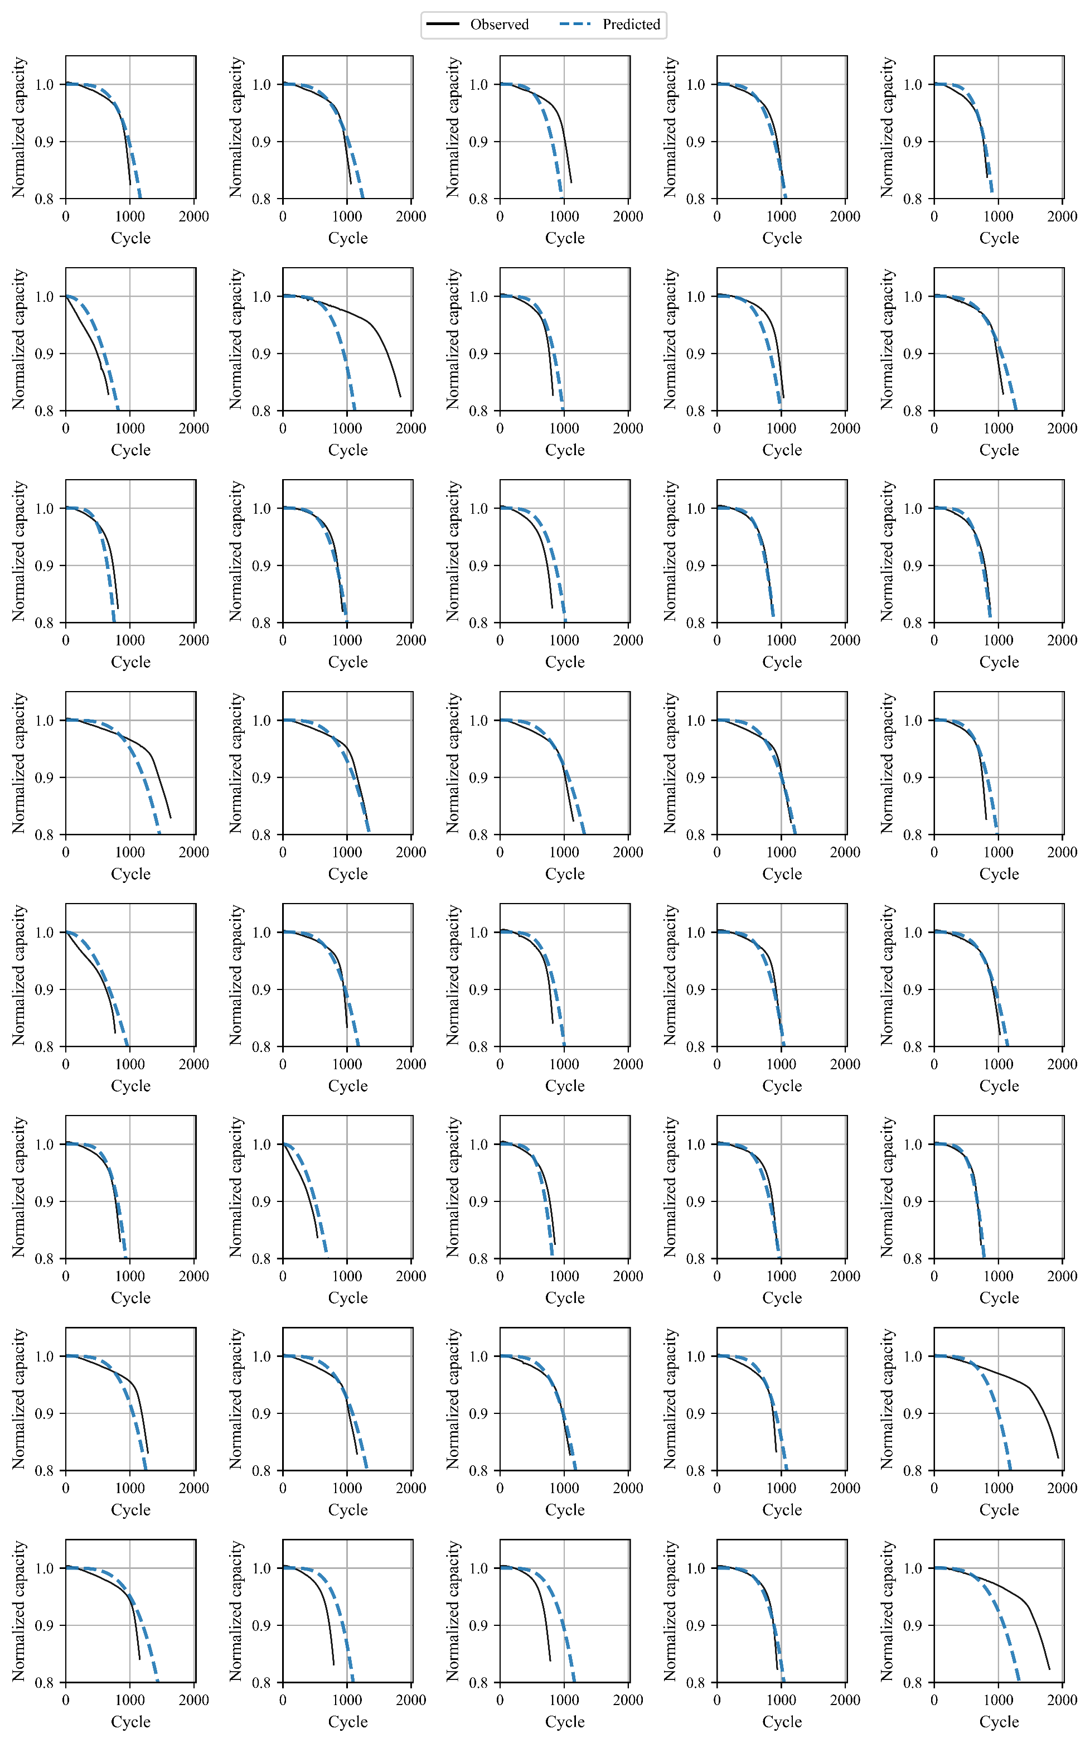

Figure S31. Predicted capacity trajectories by SeqOpt-ENN-deltaQ for the test #2 cells of the 169 LFP dataset

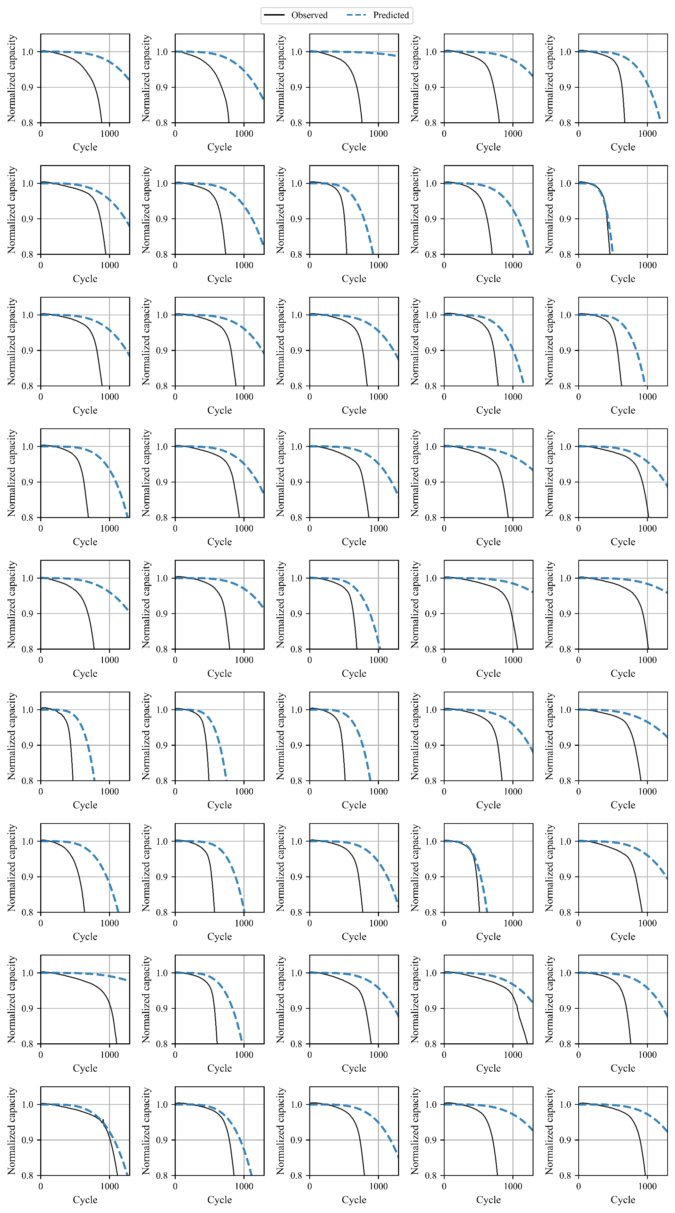

Figure S32. Predicted capacity trajectories by SeqOpt-ENN-deltaQ for the test #3 cells of the 169 LFP dataset

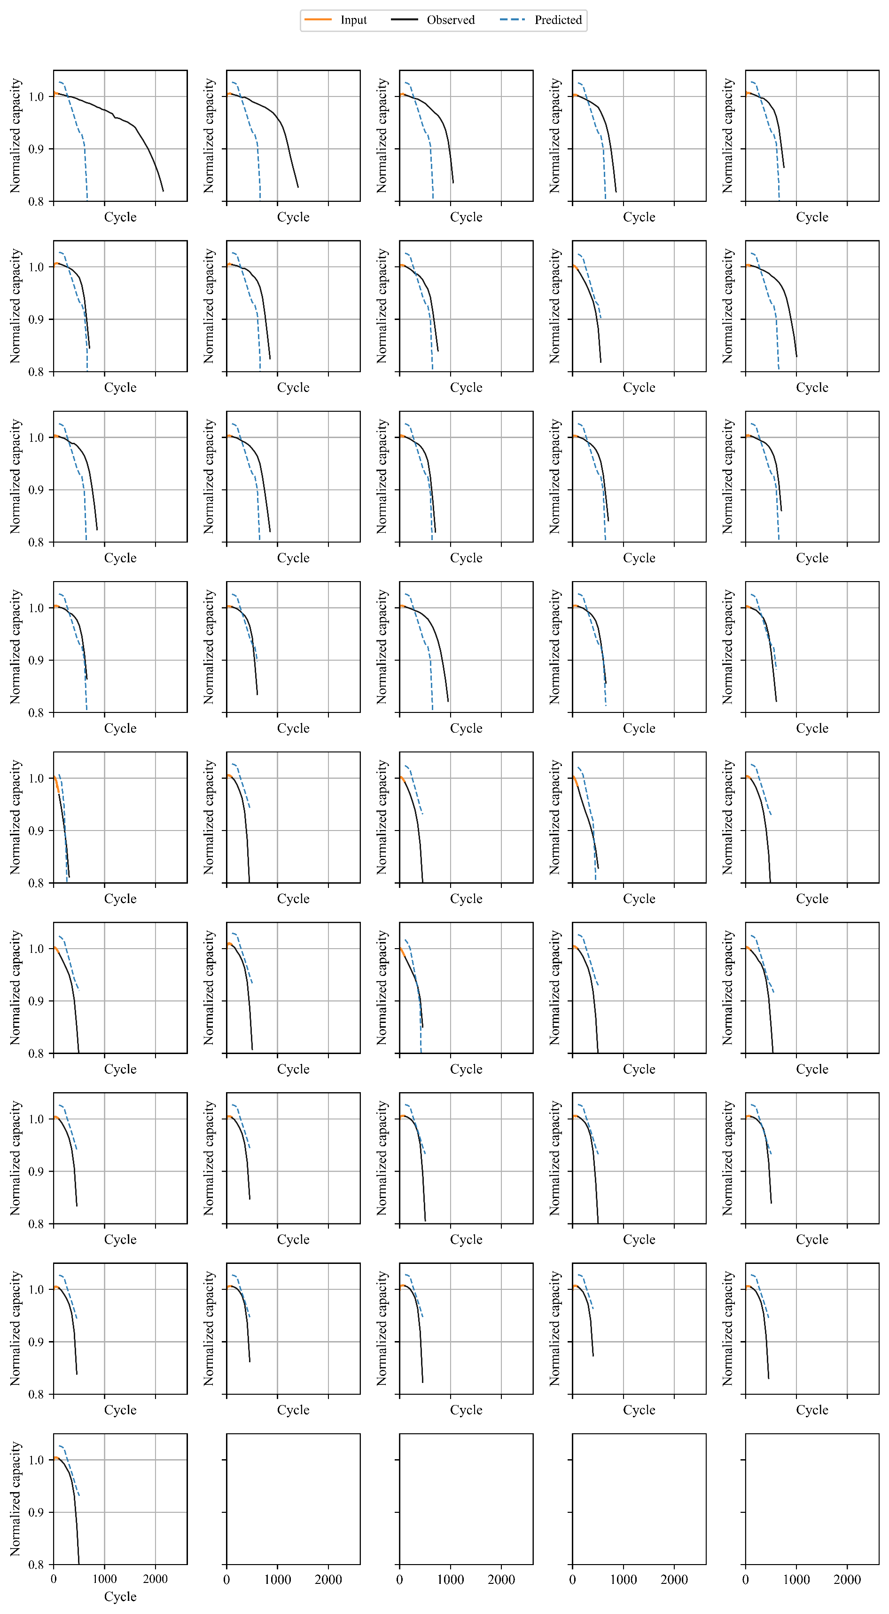

Figure S33. Predicted capacity trajectories by S2S-LSTM-100-cycle for the train cells of the 169 LFP dataset

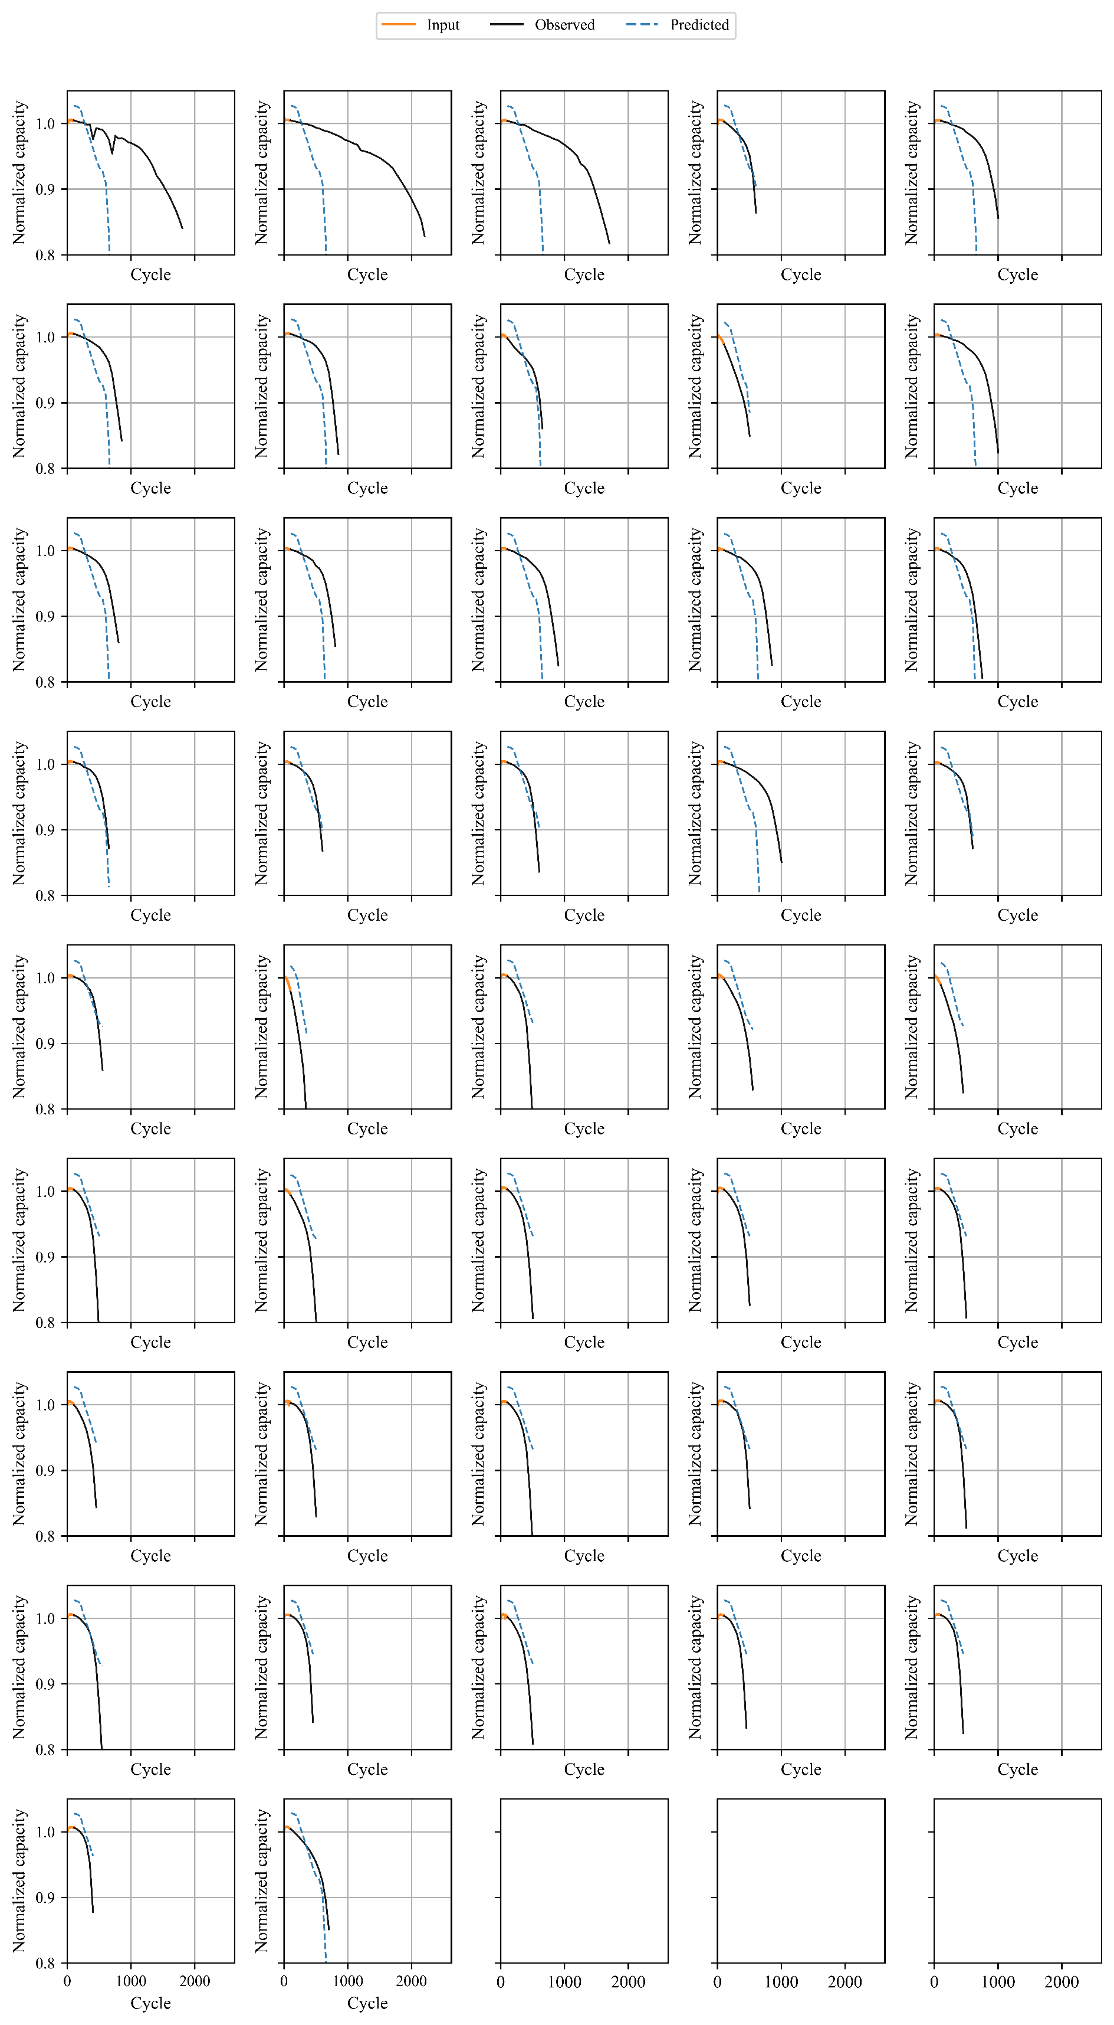

Figure S34. Predicted capacity trajectories by S2S-LSTM-100-cycle for the test #1 cells of the 169 LFP dataset

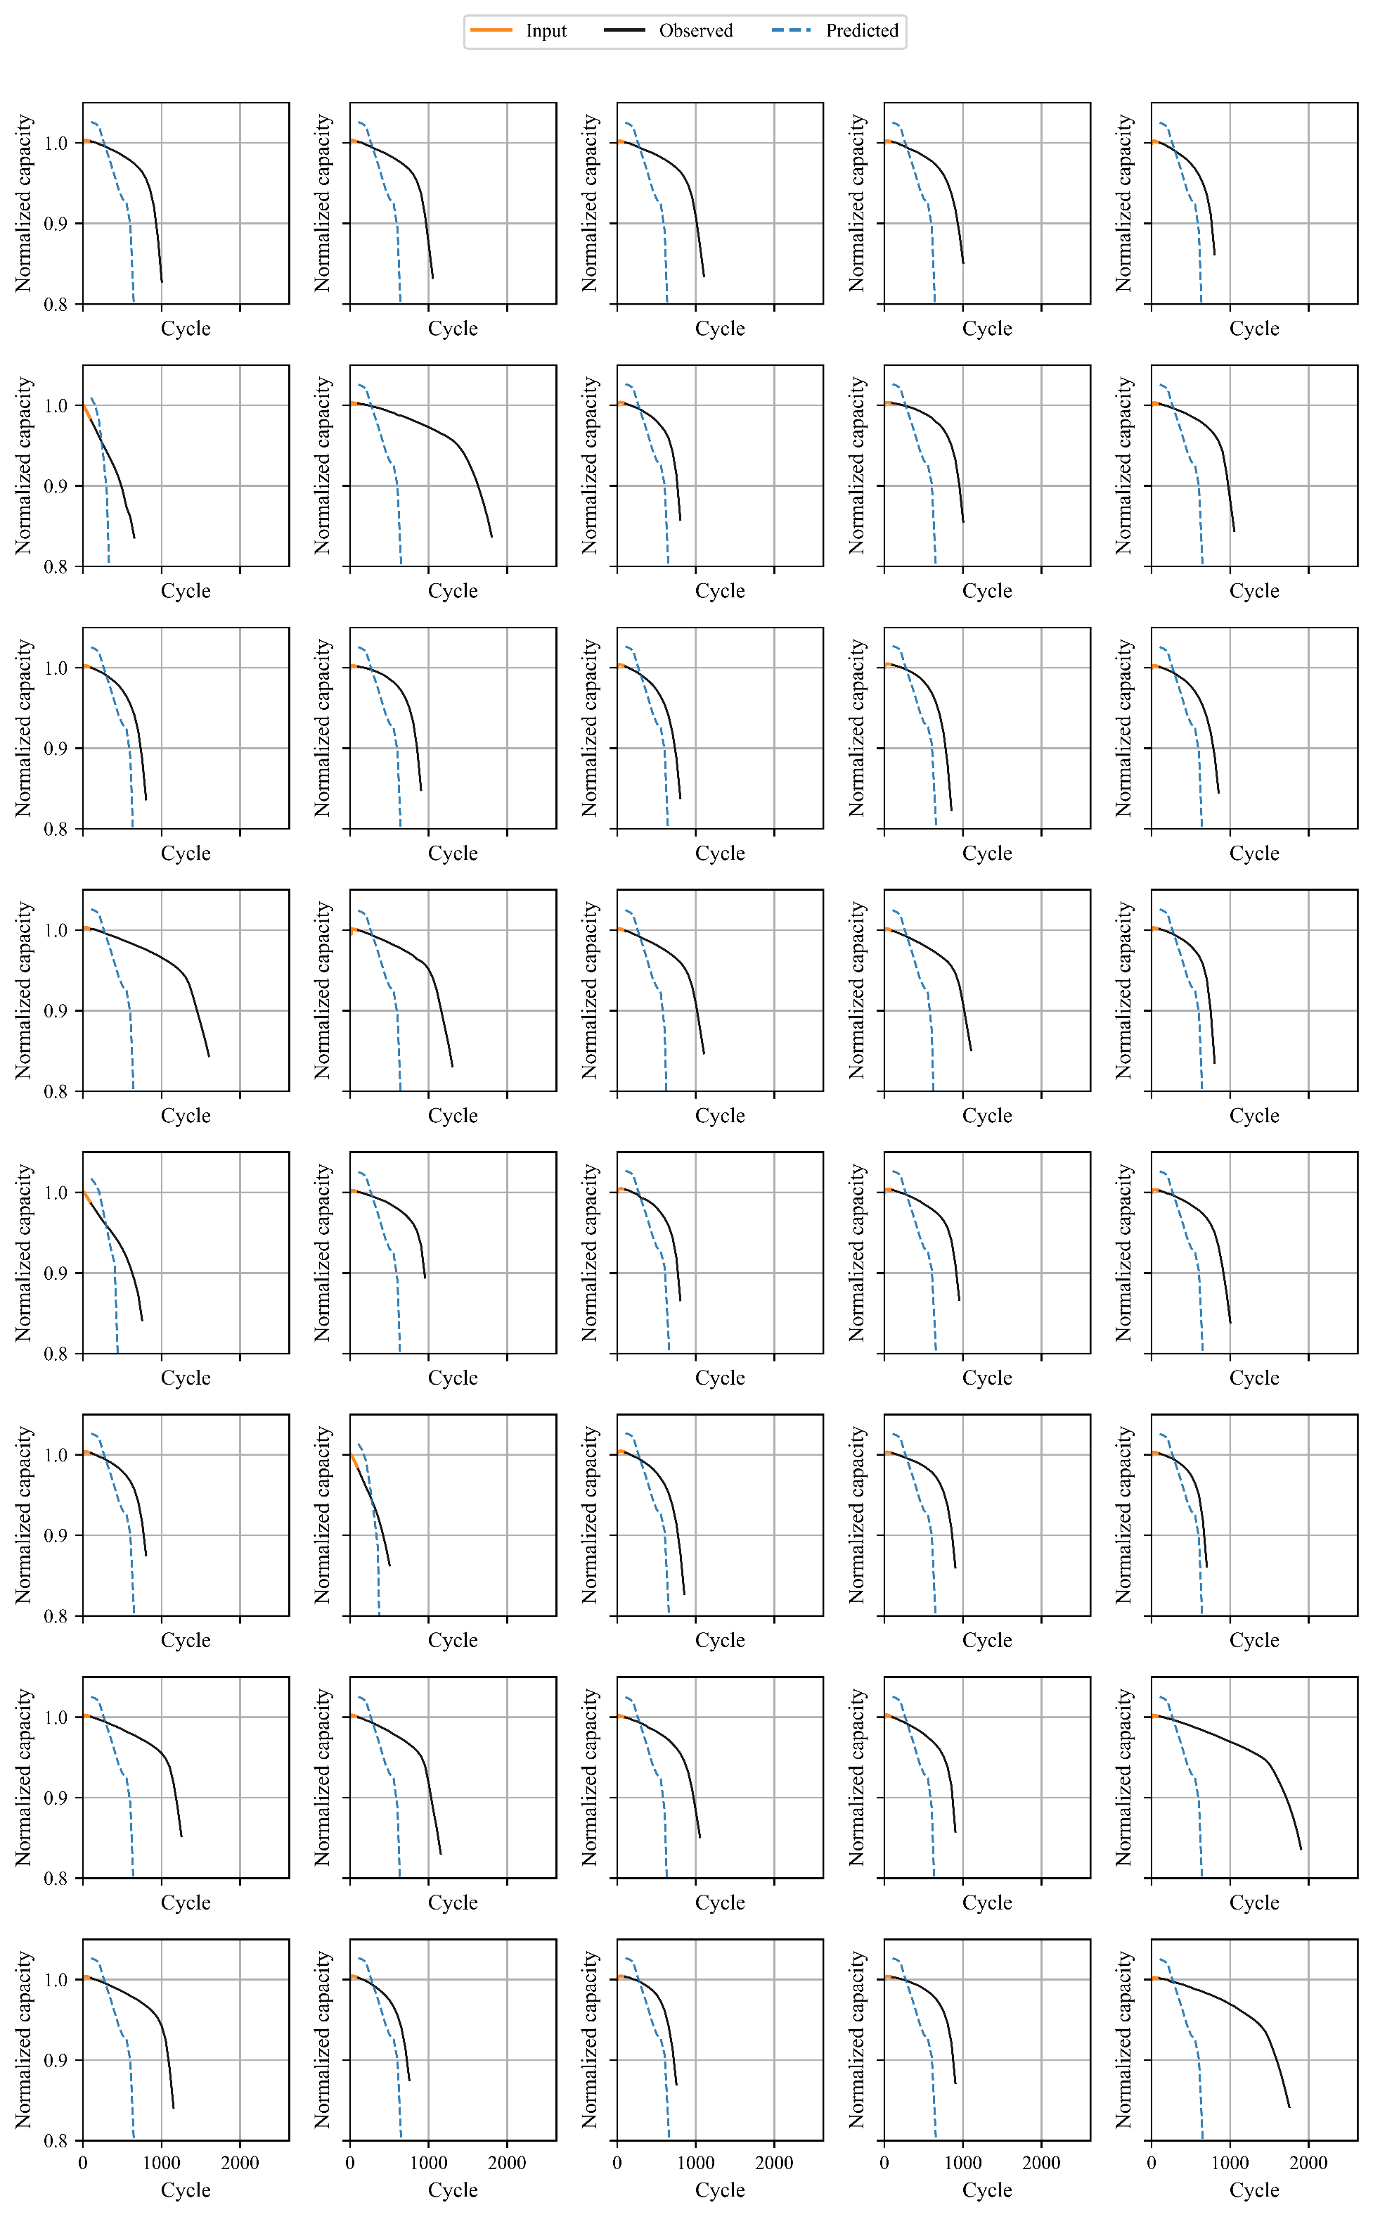

Figure S35. Predicted capacity trajectories by S2S-LSTM-100-cycle for the test #2 cells of the 169 LFP dataset

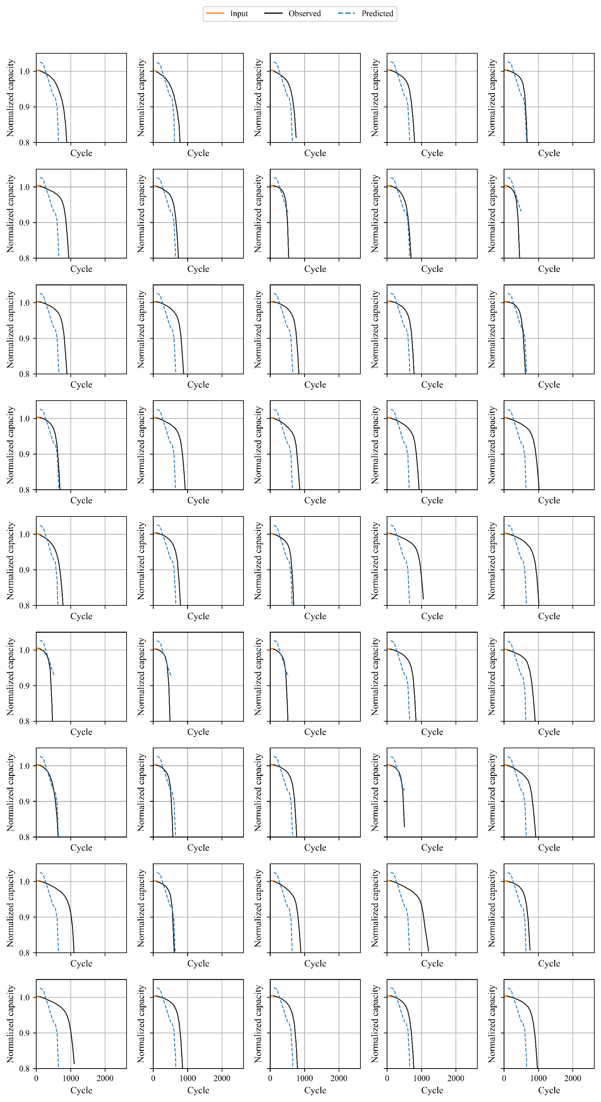

Figure S36. Predicted capacity trajectories by S2S-LSTM-100-cycle for the test #3 cells of the 169 LFP dataset

Figure S37. Predicted capacity trajectories by S2S-LSTM-200-cycle for the train cells of the 169 LFP dataset

Figure S38. Predicted capacity trajectories by S2S-LSTM-200-cycle for the test #1 cells of the 169 LFP dataset

Figure S39. Predicted capacity trajectories by S2S-LSTM-200-cycle for the test #2 cells of the 169 LFP dataset

Figure S40. Predicted capacity trajectories by S2S-LSTM-200-cycle for the test #3 cells of the 169 LFP dataset

Figure S41. Predicted capacity trajectories by S2S-LSTM-300-cycle for the train cells of the 169 LFP dataset

Figure S42. Predicted capacity trajectories by S2S-LSTM-300-cycle for the test #1 cells of the 169 LFP dataset

Figure S43. Predicted capacity trajectories by S2S-LSTM-300-cycle for the test #2 cells of the 169 LFP dataset

Figure S44. Predicted capacity trajectories by S2S-LSTM-300-cycle for the test #3 cells of the 169 LFP dataset

Figure S45. Predicted capacity trajectories by E2E-ENN-discharge for the train cells of the 48 NMC dataset.

Figure S46. Predicted capacity trajectories by E2E-ENN-deltaQ for the train cells of the 48 NMC dataset

Figure S47. Predicted capacity trajectories by SeqOpt-ENN-discharge for the train cells of the 48 NMC dataset.

Figure S48. Predicted capacity trajectories by SeqOpt-ENN-deltaQ for the train cells of the 48 NMC dataset

Figure S49. Predicted capacity trajectories by E2E-ENN-discharge for the test cells of the 48 NMC dataset

Figure S50. Predicted capacity trajectories by E2E-ENN-deltaQ for the test cells of the 48 NMC dataset

Figure S51. Predicted capacity trajectories by SeqOpt-ENN-discharge for the test cells of the 48 NMC dataset

Figure S52. Predicted capacity trajectories by SeqOpt-ENN-deltaQ for the test cells of the 48 NMC dataset

Figure S53. Predicted capacity trajectories by S2S-LSTM-100-cycle for the train cells of the 48 NMC dataset

Figure S54. Predicted capacity trajectories by S2S-LSTM-200-cycle for the train cells of the 48 NMC dataset

Figure S55. Predicted capacity trajectories by S2S-LSTM-300-cycle for the train cells of the 48 NMC dataset

Figure S56. Predicted capacity trajectories by S2S-LSTM-100-cycle for the test cells of the 48 NMC dataset

Figure S57. Predicted capacity trajectories by S2S-LSTM-200-cycle for the test cells of the 48 NMC dataset

Figure S58. Predicted capacity trajectories by S2S-LSTM-300-cycle for the test cells of the 48 NMC dataset